

1. **Introduction**

In recent years, with the development of science and technology, more and more new nanocomposites are created. Some of them can be applied in some important field. The thermal conductivity of material is one of the important properties of material. It may affect the way we use the material. At present, great progress has been made in the study of thermal conductivity of materials. Basically, there are two classic approaches: finite element simulation and formula derived from Effective Medium Theory (EMT). But these two methods both have respective drawbacks. The Finite element method usually cost huge amount of calculation. While formulas derived from EMT are usually complex and inconsistent and only fit for one specific situation. With the development and maturity of neural networks, machine learning has gradually become an important tool for researchers to find the potential relationship between factors and results. In this work, we proposed and designed a machine learning-based solution to accurately predict the thermal conductivity of composite material base on the material properties.

Our primary thesis is we can use the neural network model to find the shape factor for different particle shapes, so they can fit into the formula presented in Nan et al. Besides, we also tried to use the neural network to predict the conductivity directly, but the results turn out to be too noisy to be used.

1. **Background and related work**

/* leave blank */

1. **Design**

Our basic assumption is that there exists a non-linear relationship between the properties of the composite materials and their thermal conductivity. We can use neural network to capture this relationship by training on the know dataset and apply neural network to the thermal conductivity prediction for other material.

**3.1 Date generation**

We followed the formulas derived by Ce-Wen Nan *et al.,* to generate data. We first studied the case of Completely misoriented ellipsoidal particles. Five parameters are regarded in this case: $K_{p}$ (the thermal conductivity of disperse phase), $K_{m}$ (the thermal conductivity of matrix phase), $a_{k}$ (the Kapitza radius, which characterizes the interface thermal property), $f$ (the volume fraction of the disperse phase) and $shape$ (a vector that contains the length of semi-axes of the ellipsoid). Data was generated randomly, with $K_{p}, K_{m}∈(0,100)$; $a_{k}=0; f∈\left(0, 1\right); semiaxis∈\left(0, 1\right).$ At the same time, we compute the volume, surface area, and projection area for each ellipsoidal particle. In Nan’s paper, they defined a parameter p to characterize the shape of the particle. p is defined as the ratio of semi-axes of the ellipsoid. We use these parameters to characterize the shape of the particle. We generate 100,000 entries for the training set and 100 entries for the test set.

**3.2 Model Training**

We train two models: one for predicting conductivity from parameters: Kp, Km, f and p. Where p is the parameter to characterize the shape of the particle. The other model is for predicting p (the shape factor) from the other shape parameters such as surface area, volume and projection area. Since our work can be classified as the regression problem in machine learning theory. Our neural network model leverage the MLP regressor from the scikit learn library. The model is illustrated as the figure below:

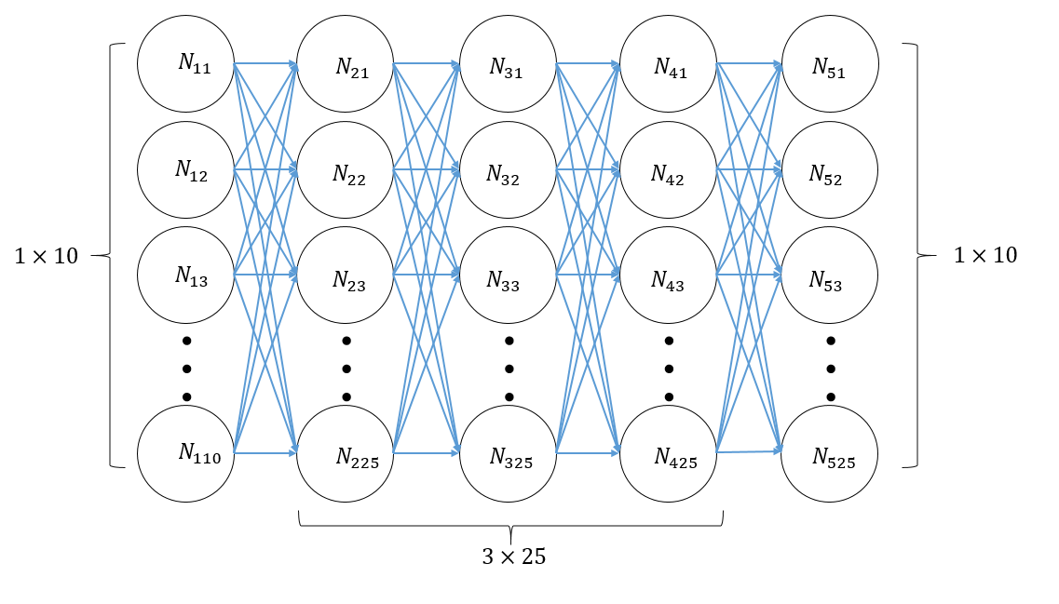

**3.2.1 K model**

For the conductivity predicting model, we choose the full-connect neural network regressor with 5 hidden layers. The hidden layers are arranged as 10, 25, 25, 25, 10. Experiment results suggests that this model fits our case quite well.

**3.2.2 P model**

For the shape factor predicting model, we trained 10 full-connect neural network regressors and use the mean of the 10 prediction as our final prediction. The average approach is adopted to reduce the noise and error.

1. **Evaluation**

**4.1 K model evaluation**

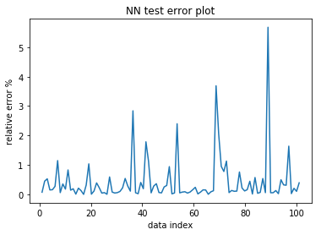

The K model gives average cost of 0.01376

The average of relative error is 0.43

The standard deviation of the relative error is 0.8016

**4.2 p model evaluation**

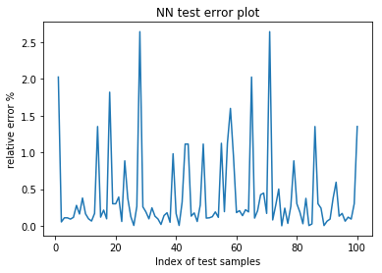

The P model give average cost of 7.4882e-6

The average of relative error is 0.4073

The standard deviation of the relative error is 0.5516

**4.3 comparison with Finite element results.**

In practice, we compute the particle shape factors (volume, surface area, projection areas) and feed them into the p model to get the predicted p value for particle. Then, we feed the p value together with the other parameters (Kp, Km, f) into the K model to get the predicted conductivity. In this way, we can predict the conductivity for all particles of any shape, as long as we know its shape parameters.

For evaluation, we studied three shapes: cones, ellipsoid, donuts. And we evaluate the conductivity with Kp, Km in exponentially increased values [0.2, 0.5, 1, 2, 5, 10, 20]. For each shape we studied two volume fractions. We chose one volume fraction randomly and the other fraction is the same for all three shapes.

**4.3.1 Ellipsoid**

We study the mis-oriented ellipsoid case first, because it was one of the model that Nan et al. has studied and our data for neural network training is also generated from the case. The finite element model for simulation is illustrated in the figure below.

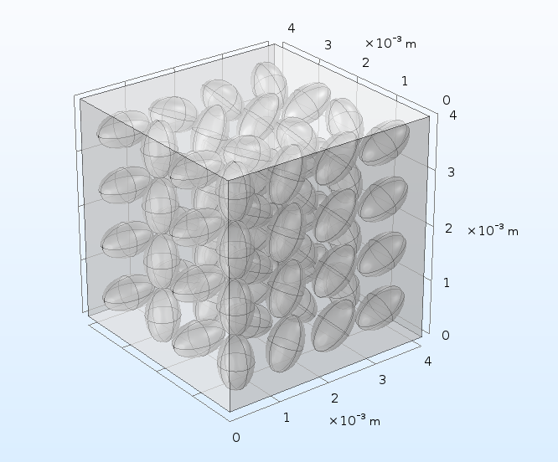

**4.3.1.1 Volume fraction:** **0.1847**

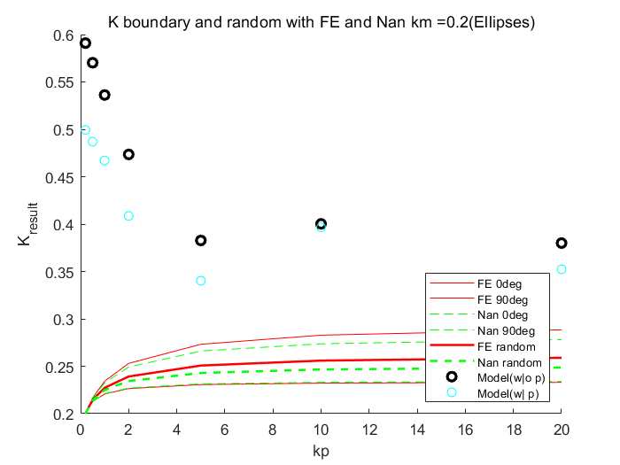 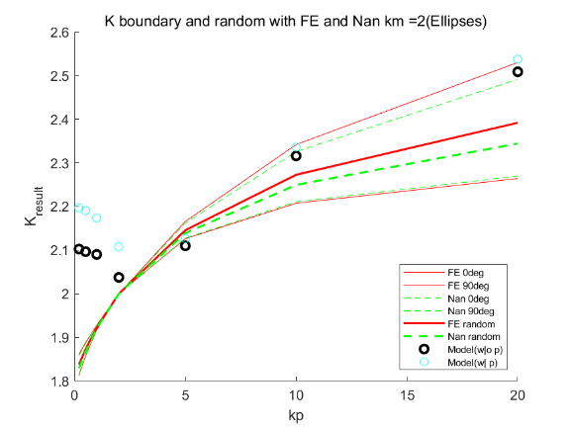

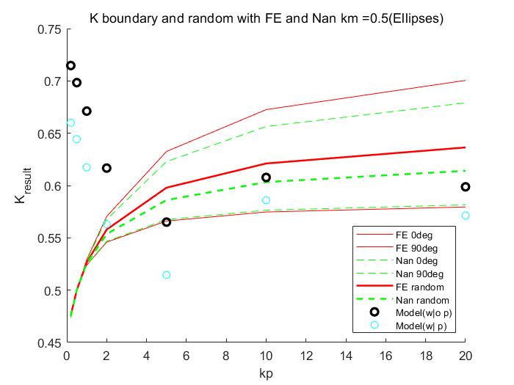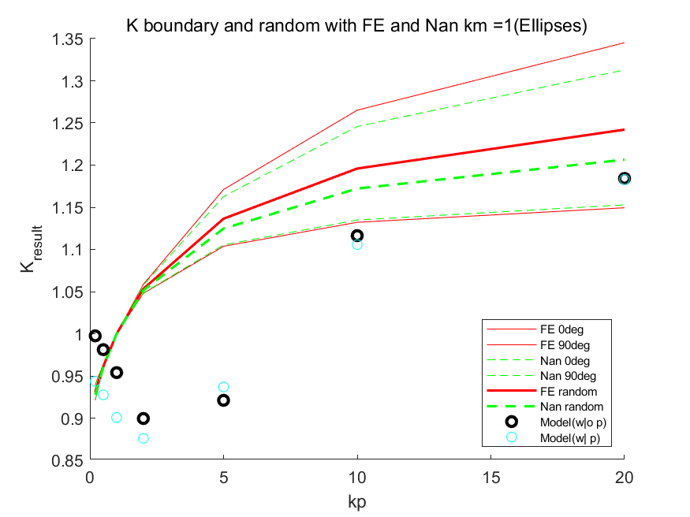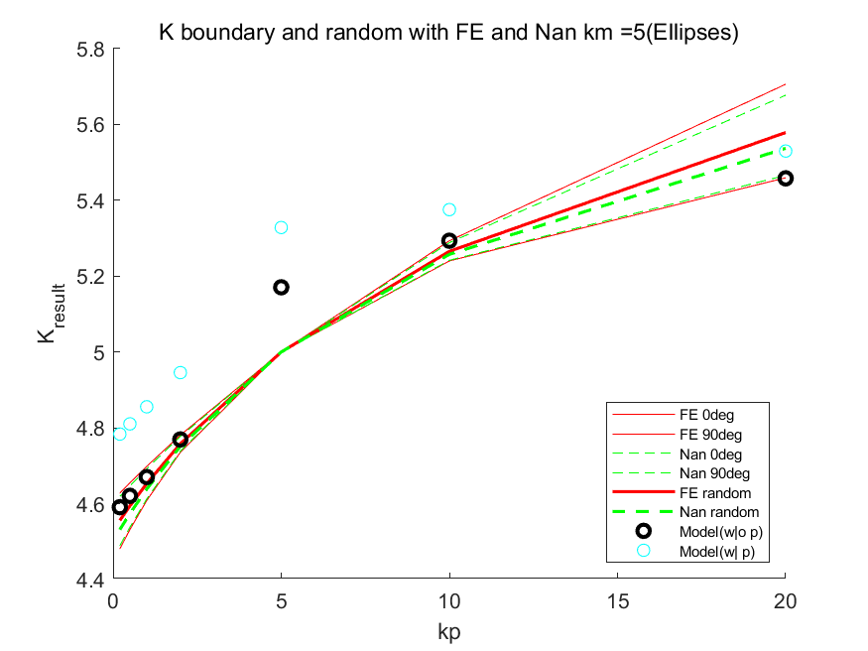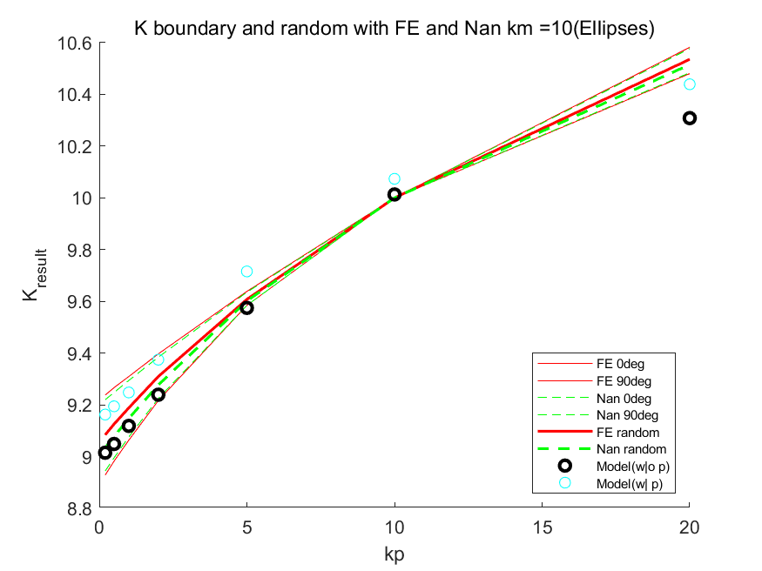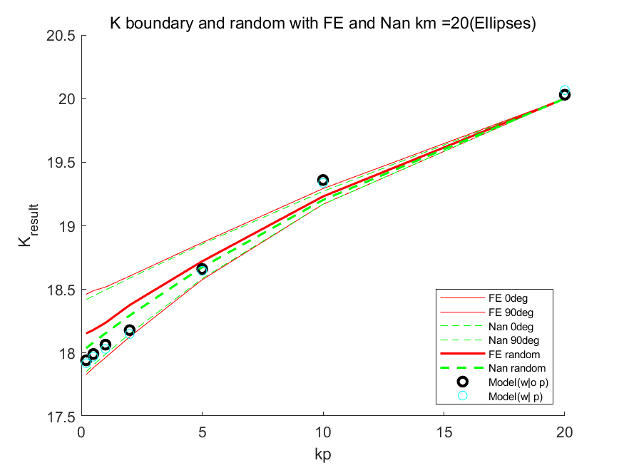

The above three graphs show the variation of conductivity values versus Kp with Km fixed. Because the angle between the direction of heat flow and the particle direction effects the conductivity. We chose two limit situations as boundary to evaluate the accuracy of the machine learning prediction. In the following context, we use FE as a short for Finite Element simulation results. Nan as a short for Formula calculation values by Nan’s paper. Model as a short for machine learning model predicted results. In each graph, we plot six curves, each represents the FE at 0 degree and 90 degrees, Nan at 0 degree and 90 degree and the randomly oriented particle cases. From the plots, we can conclude that as Km and Kp increases, the machine learning model fit the actually values better (most of the predicted value fall into the boundaries as the Kp, Km are greater than 10. When Kp or Km is small, the predicted value may fall out of the boundary.

Our second observation is that the formula provided by Nan predicted the random case quite well. Almost all the Nan’s values fall into the boundaries of FE.

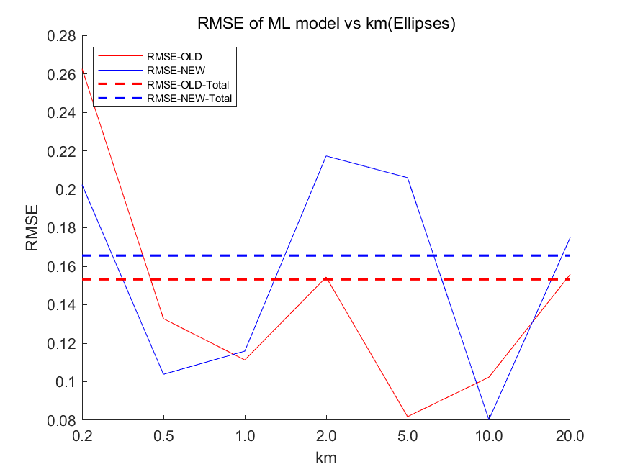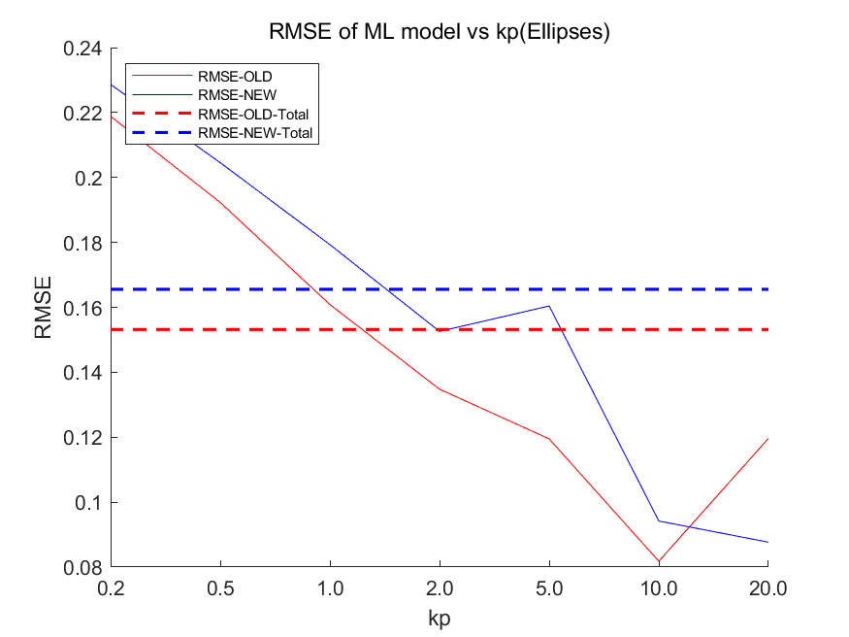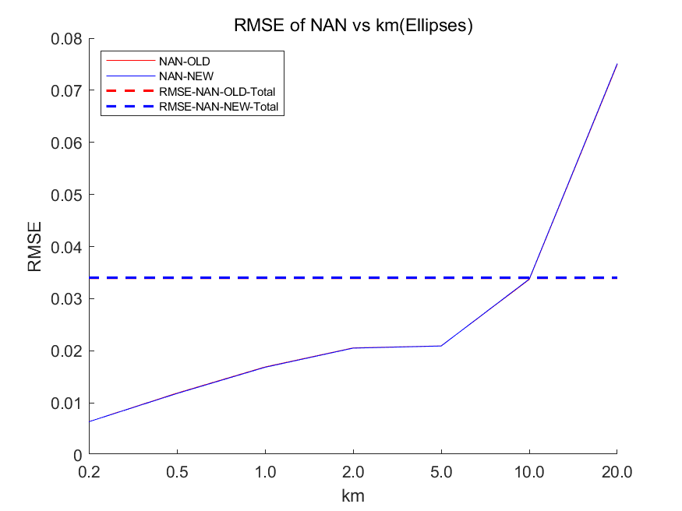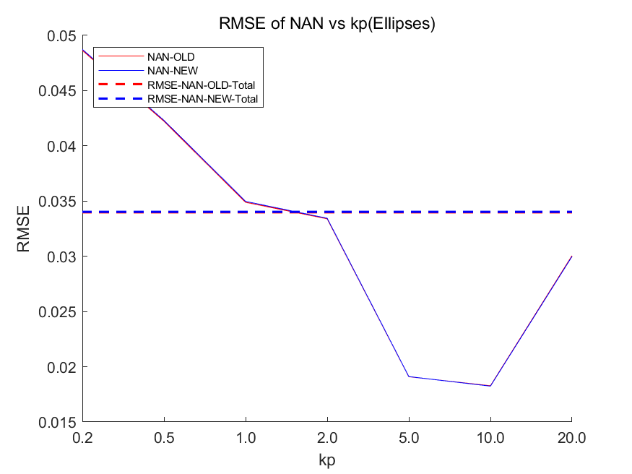

To quantify the error, we adopt the Rout Mean Square Error. We regard the FE result as the standard value and calculate the RMSE of Nan and Model for each Kp and Km and plot the results as above. We also calculate the overall RMSE for old model and new model. Here “old” means the p value is calculated as ratio of semi-axes. And “new” means the p value is predicted by the P model. From the above graph, we can observe that the model prediction for K model is not as good as Nan’s formula. However, the p value predicted by P model can give an accurate p that has almost the same RMSE as original value.

**4.3.1.1 Volume fraction:** **0.04617**

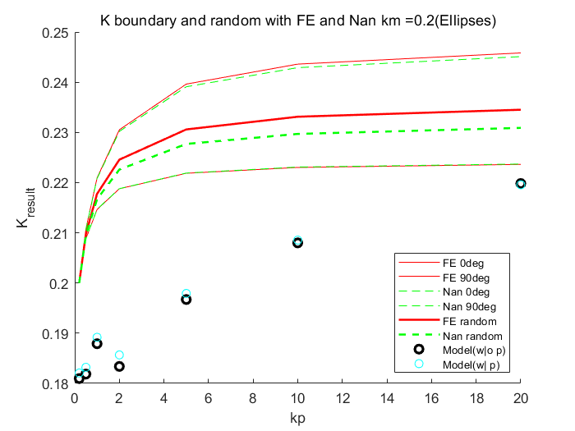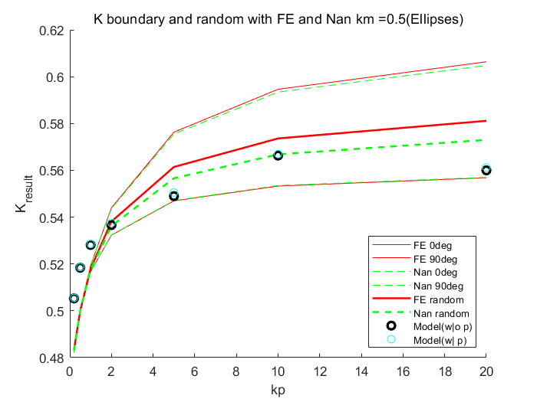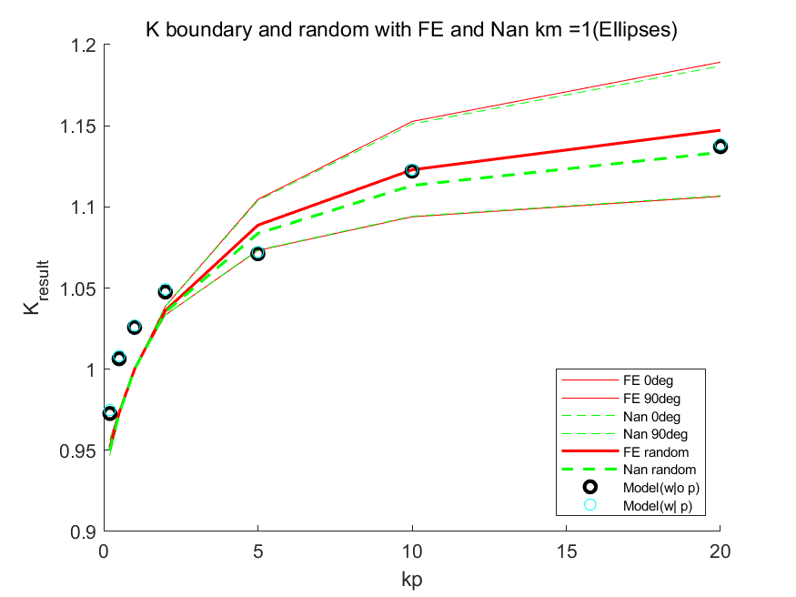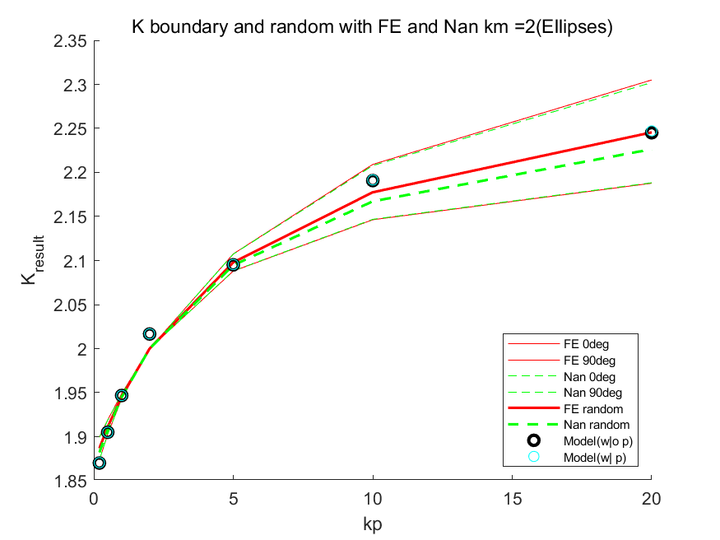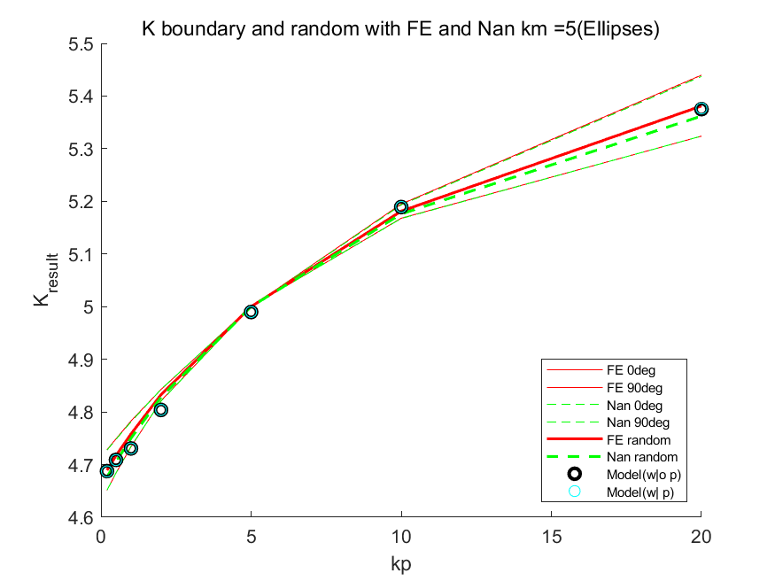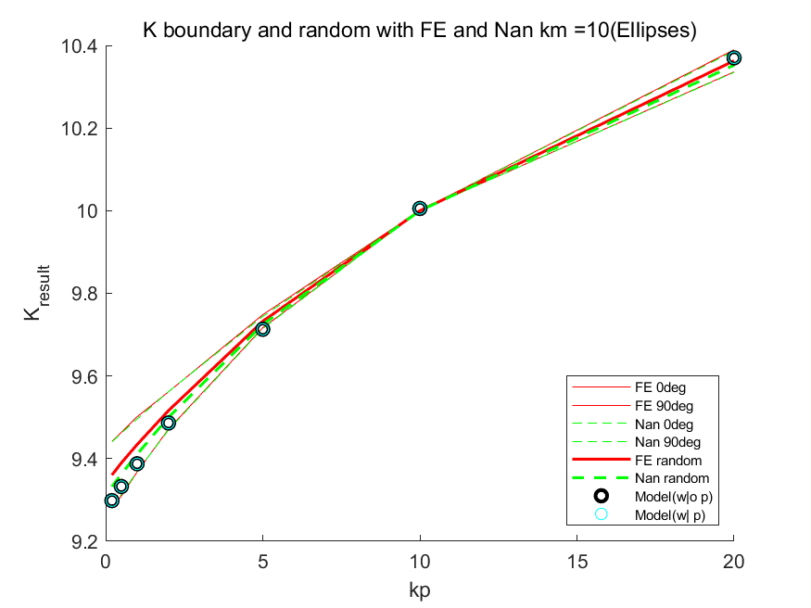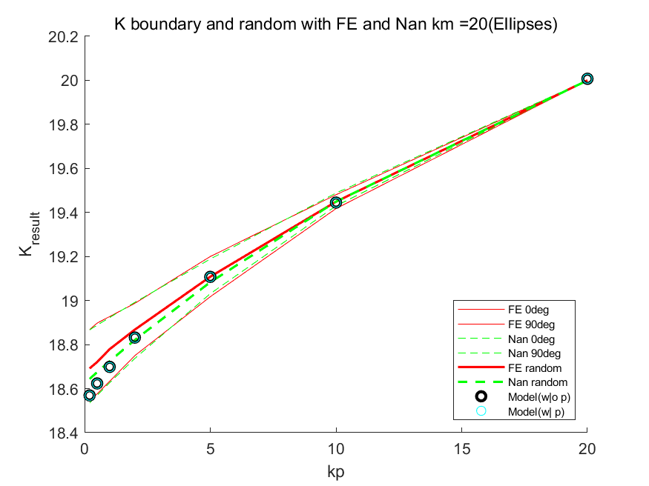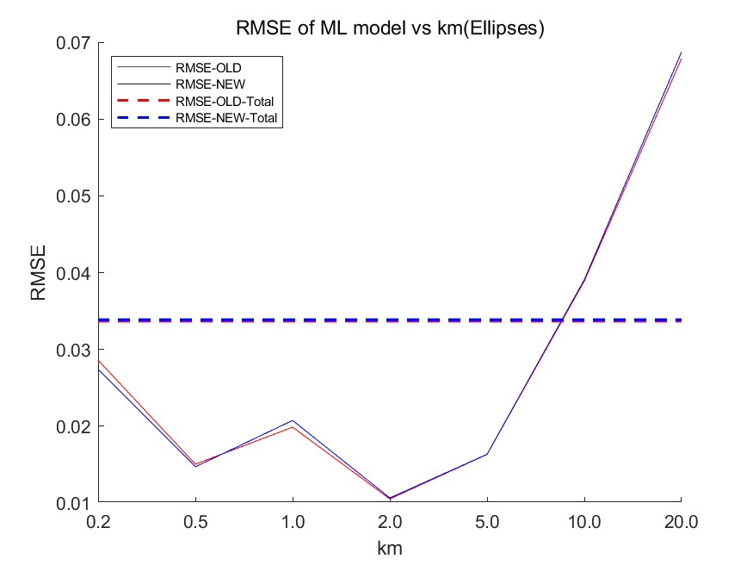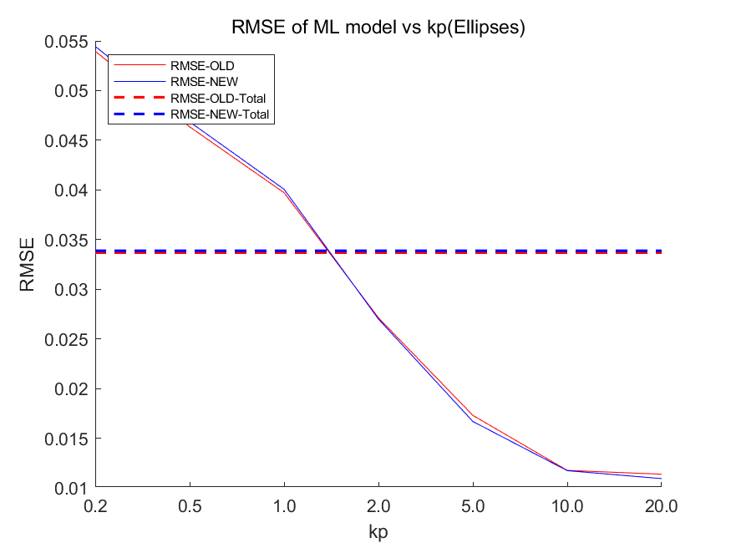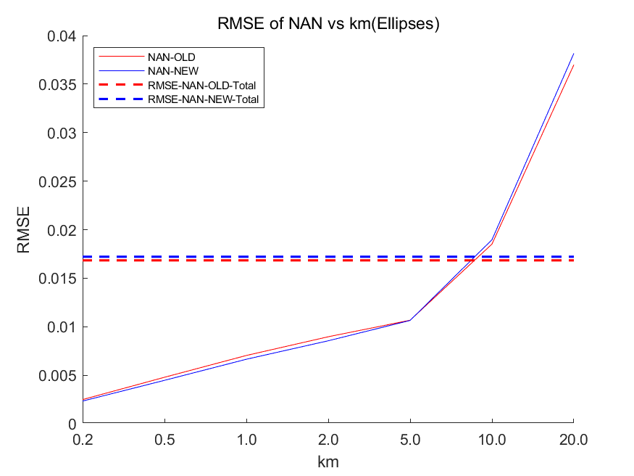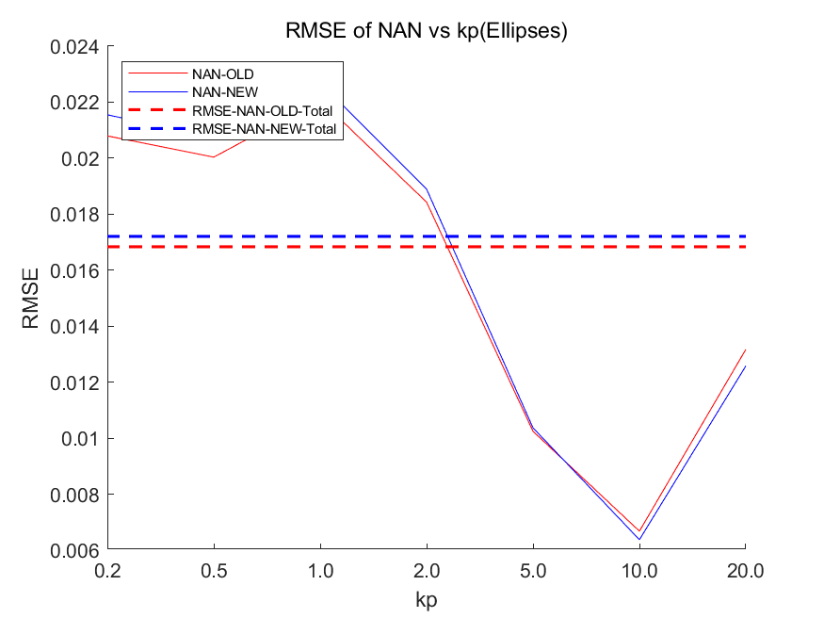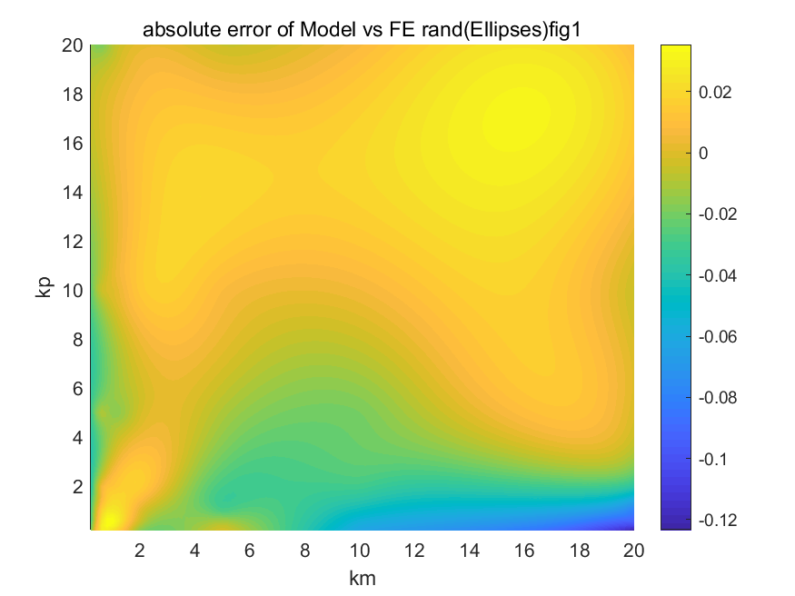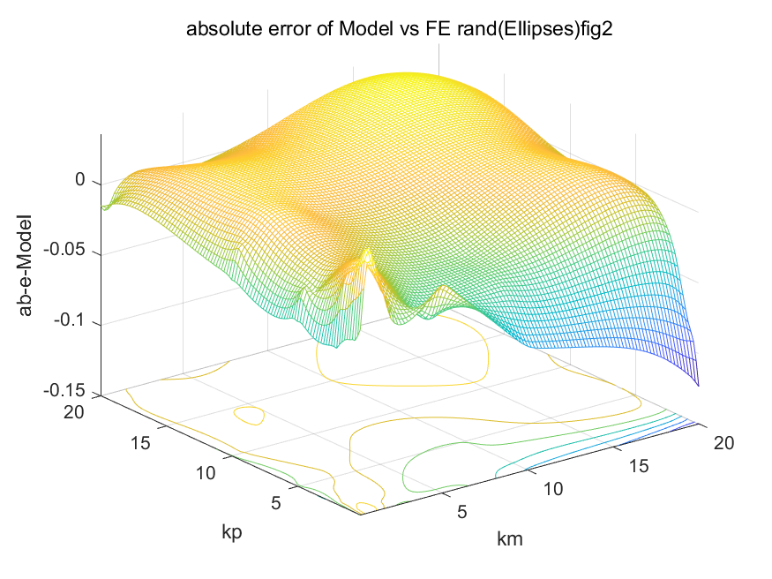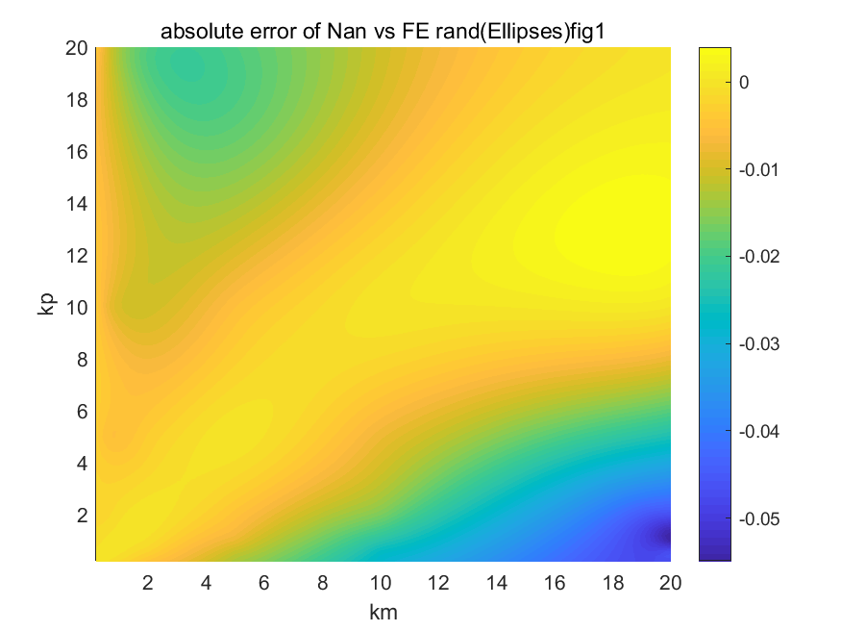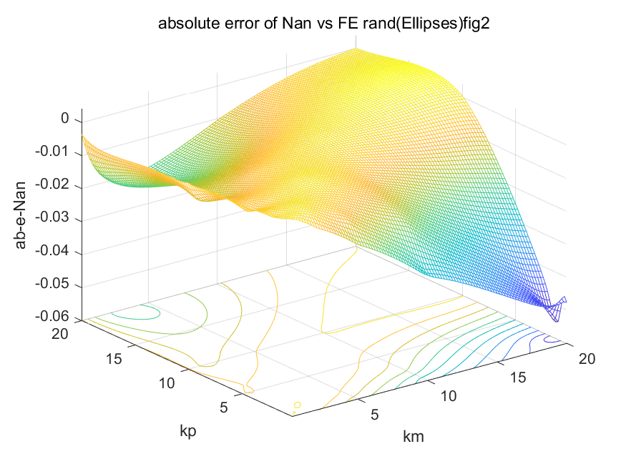

Our main contribution is presented as following: we can apply the Nan’s formula, which is derived from Effective Medium Theory dedicated for misoriented Ellipsoid, to the other shape with a proper shape factor. We refer to the shape factor as p. In Ellipsoid case, p is defined as the ratio between semi-axes. We use our p model to generate a p for cone and donut particle. And it works well in the randomly oriented particle situation.

**4.3.2 Cone: Volume Fraction: 0.04618**

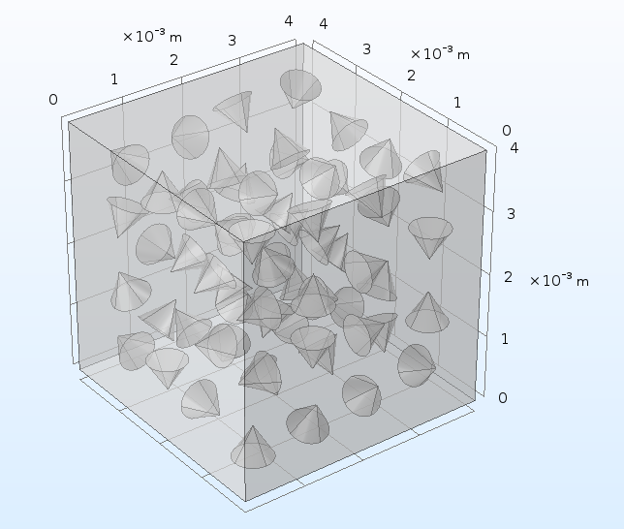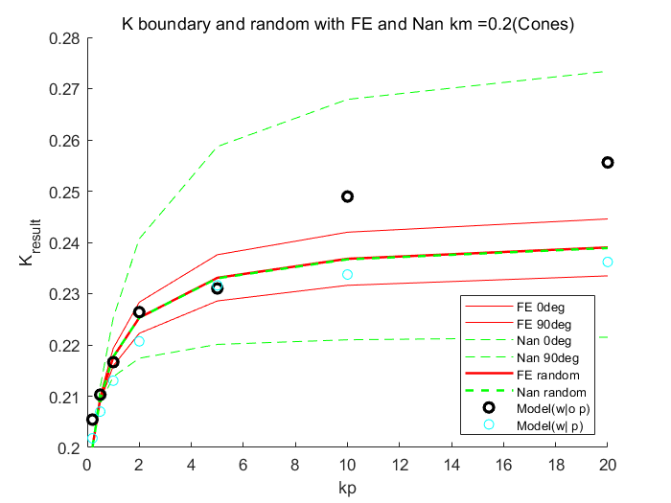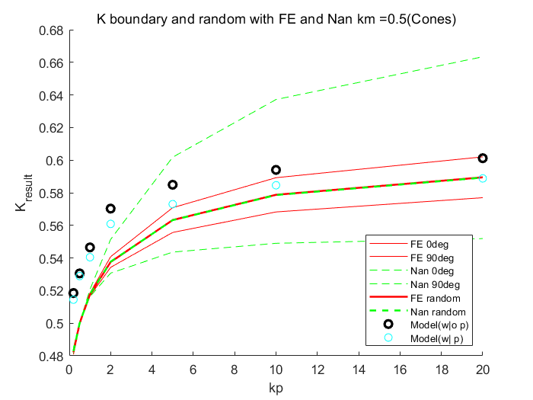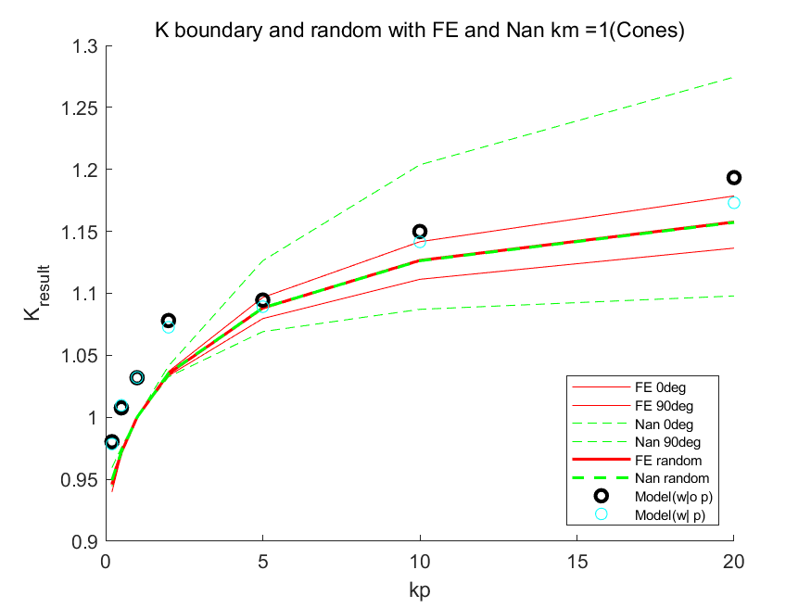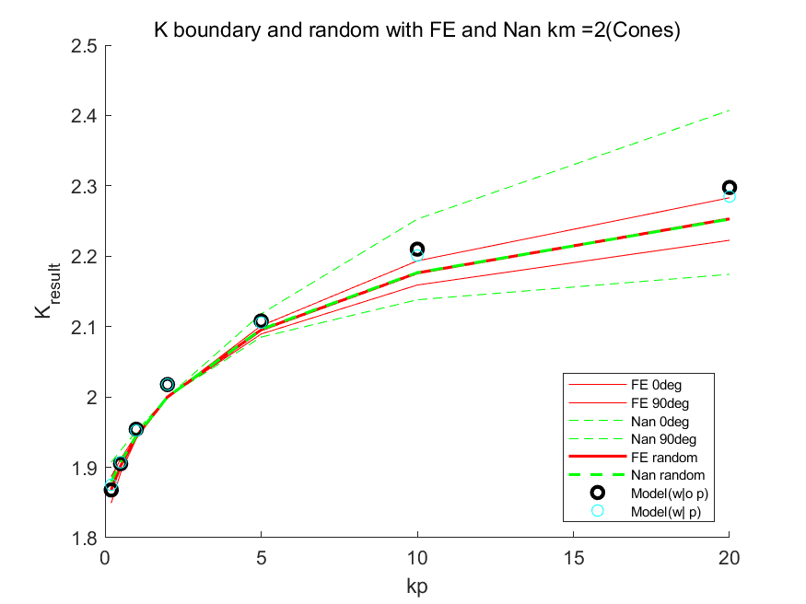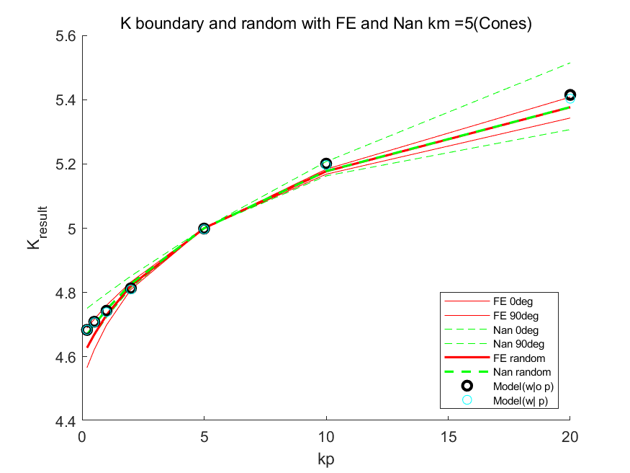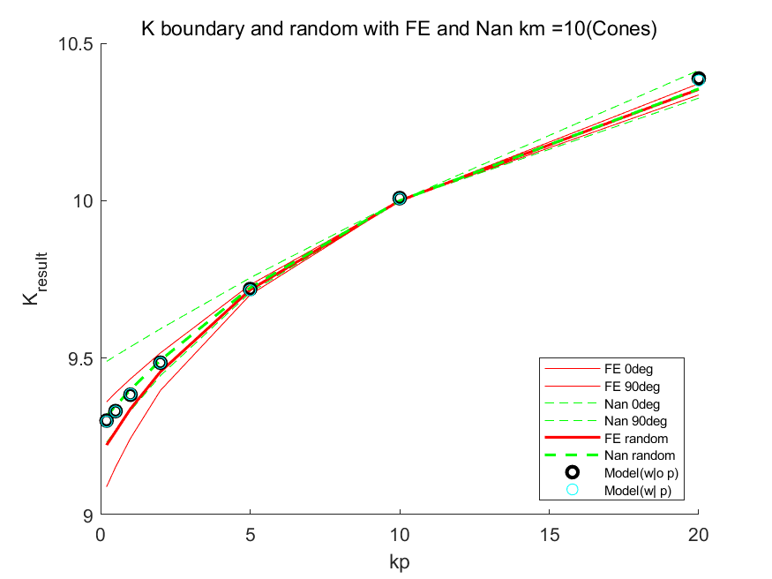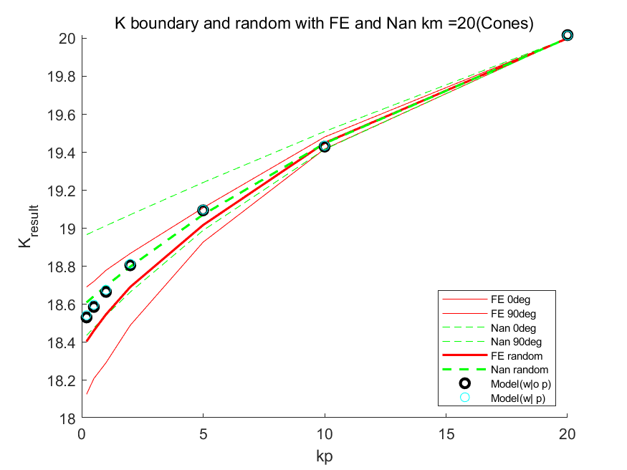

Similar result comes with K model. However, we can find that the P model gives quite a good p value that fit FE very well.

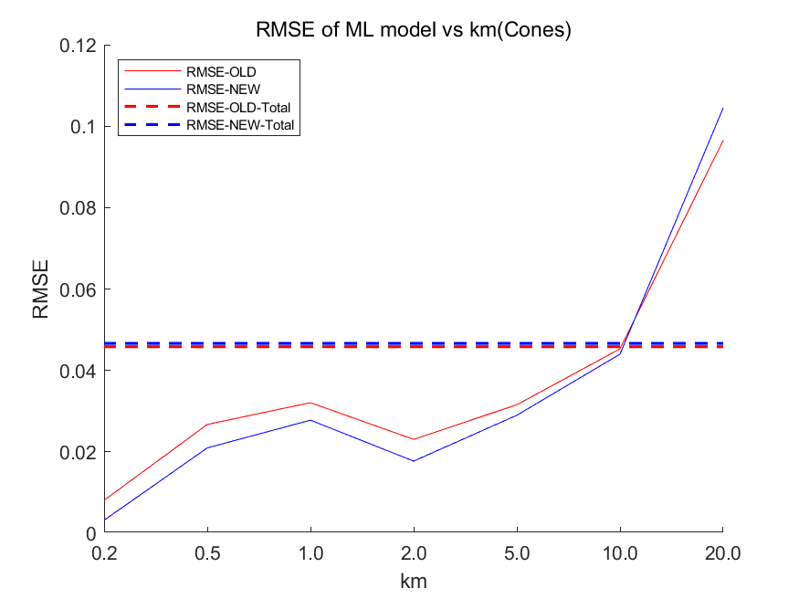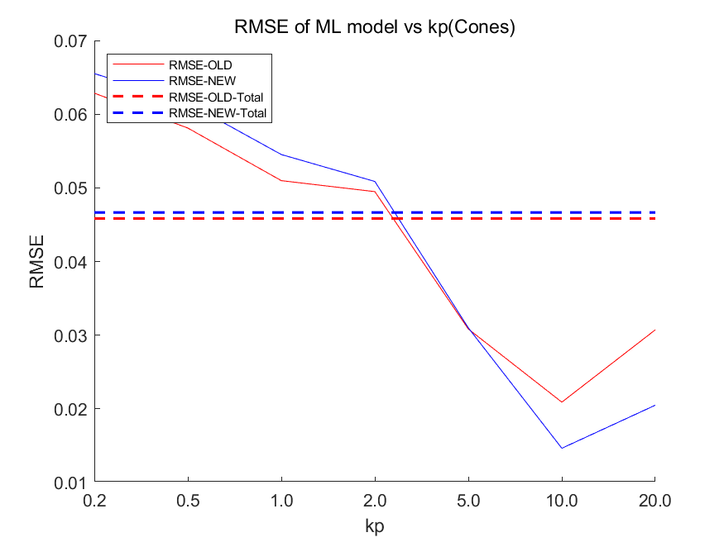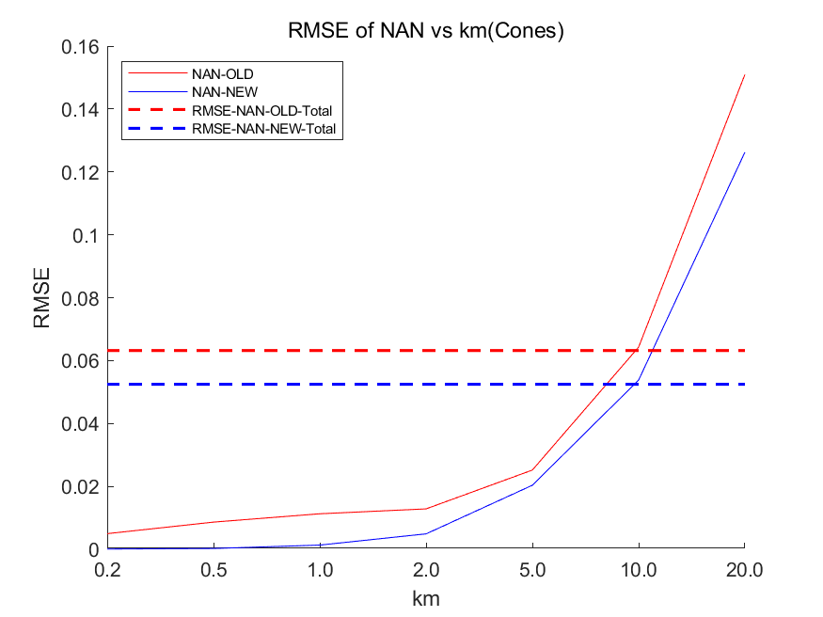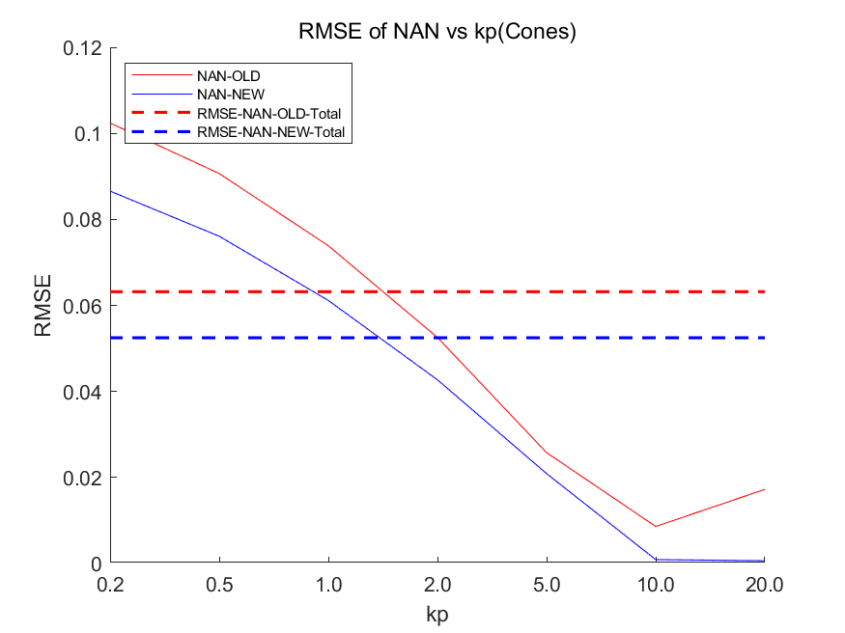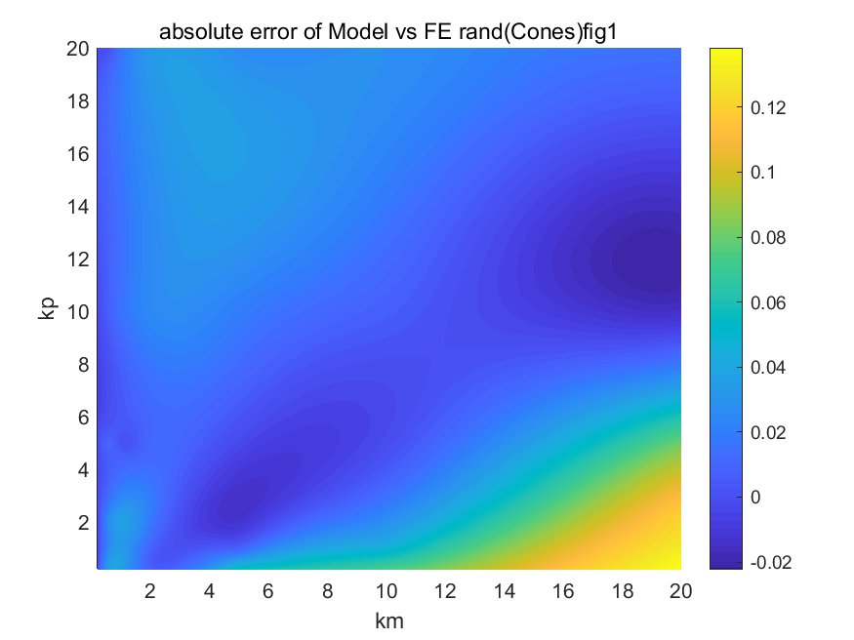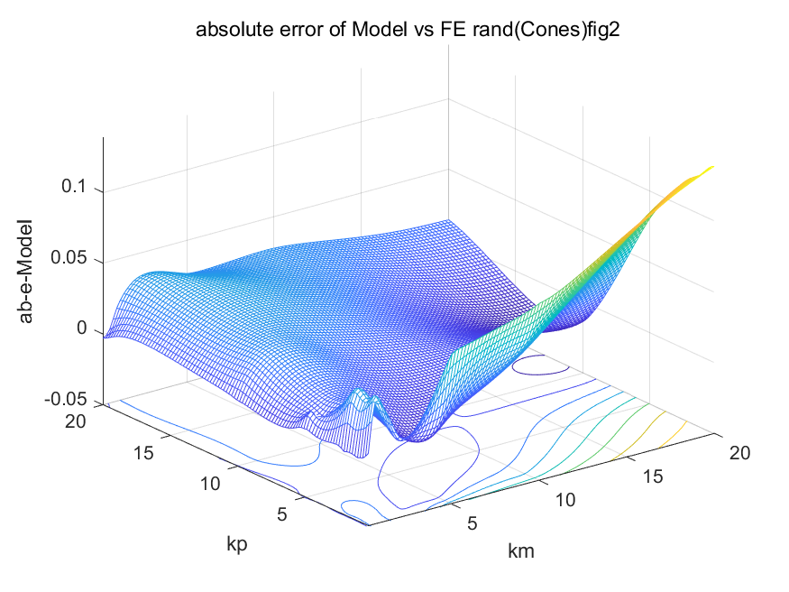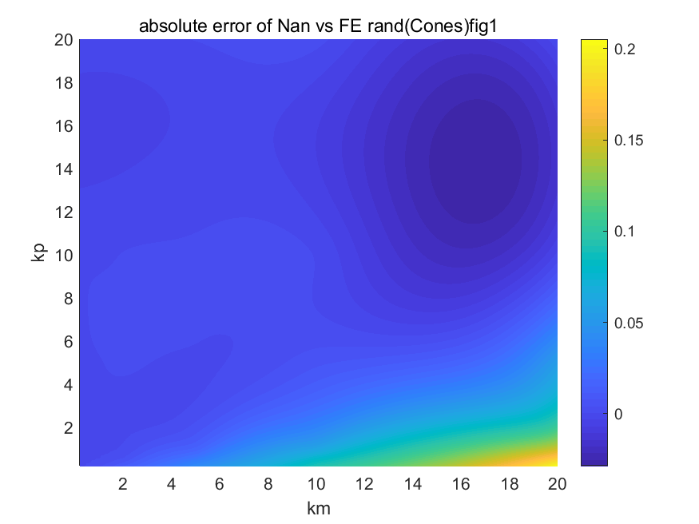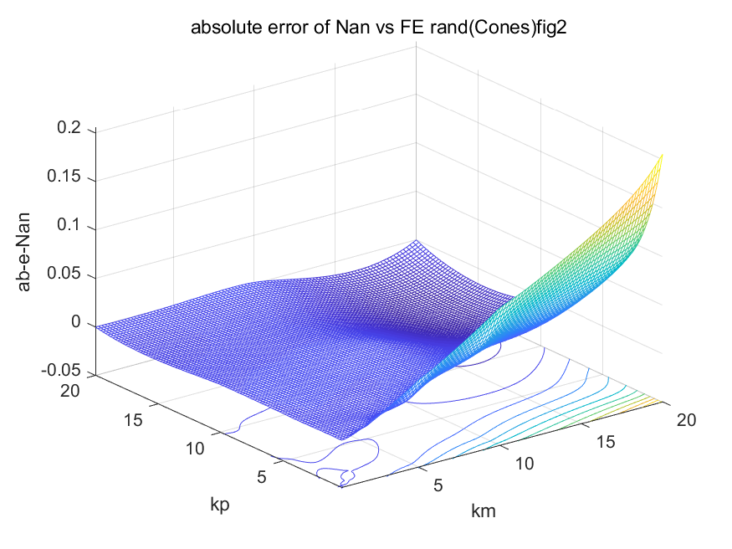

Before we use the P model to predict the p value, we guessed a p value as the ratio of height and radius of the cone (from the intuition of ellipsoid’s definition). We refer to that value as “old” and the predicted p value as “new” in the above graph. We can see that the predicted value is obviously better than the guessed value.

**4.3.3 Donut**

**4.3.3.1 Volume fraction: 0.2138**

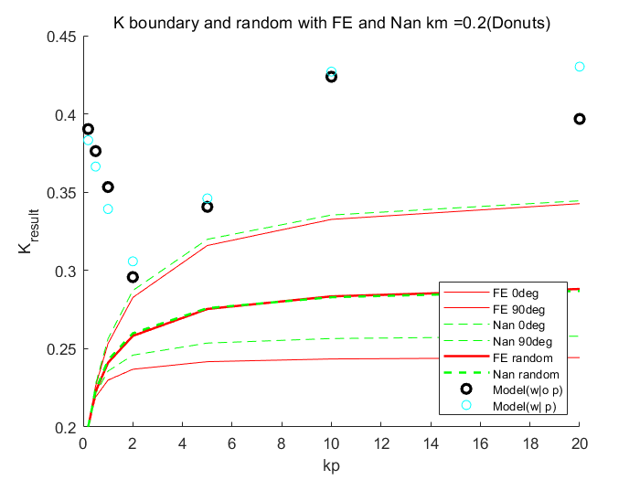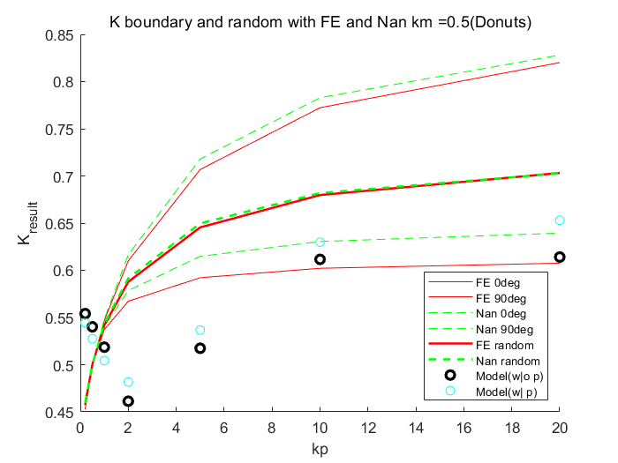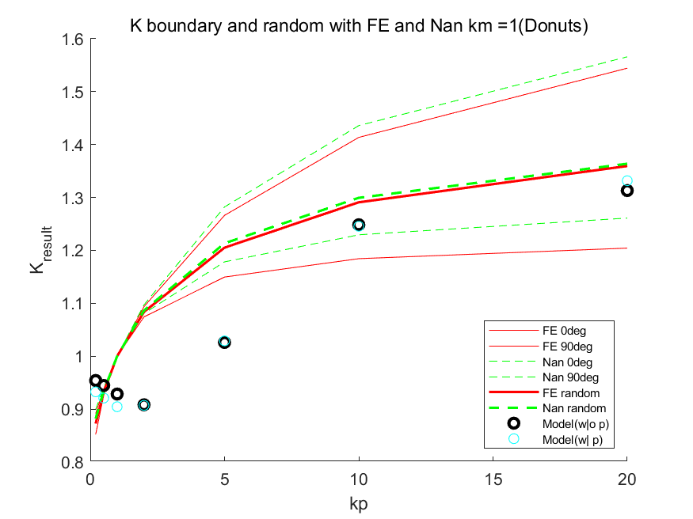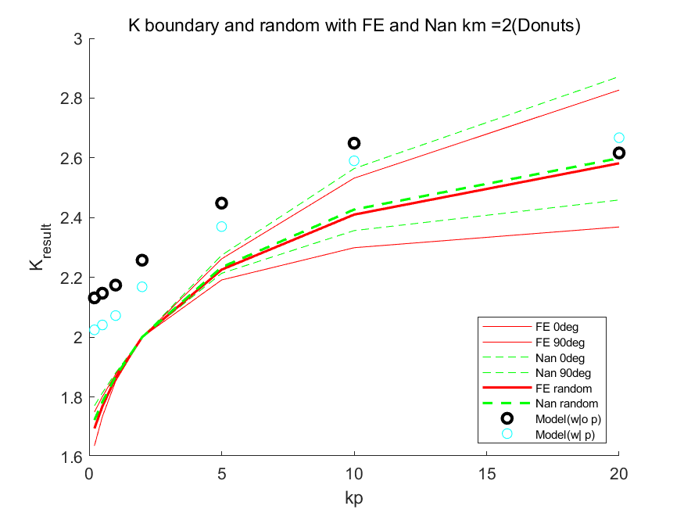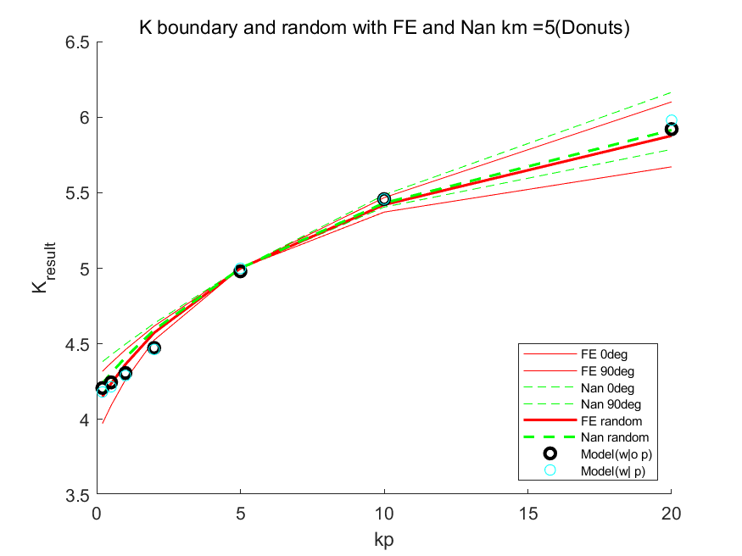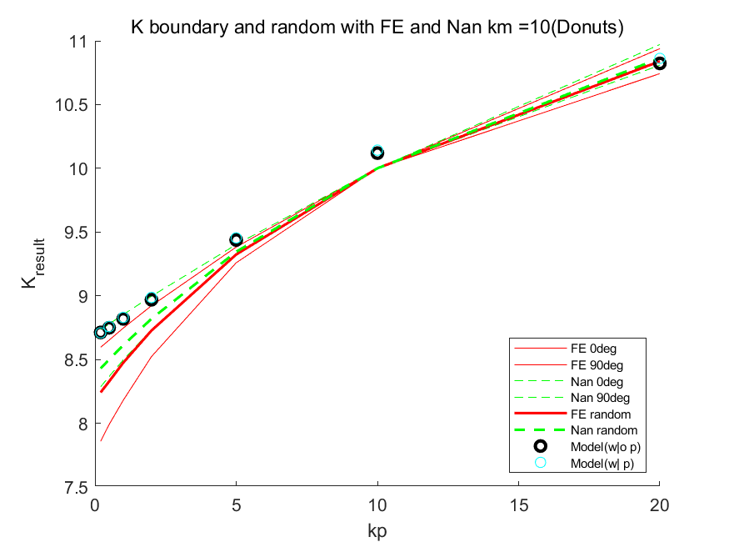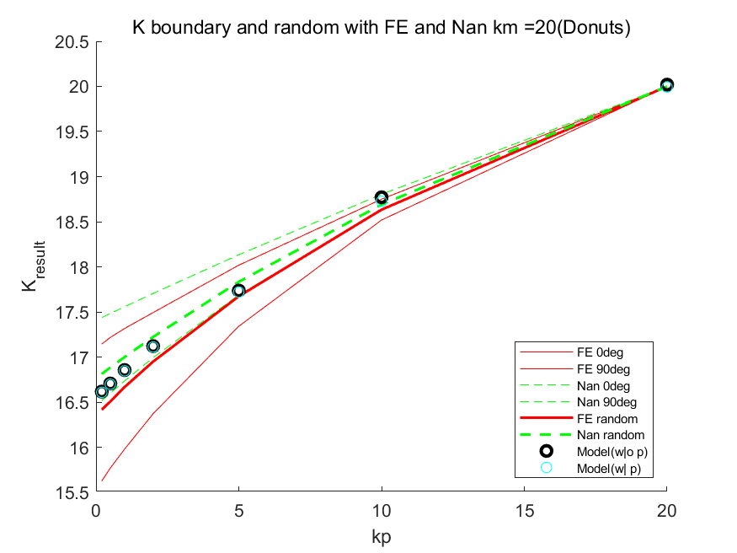

Similar result can be observe from the above plots

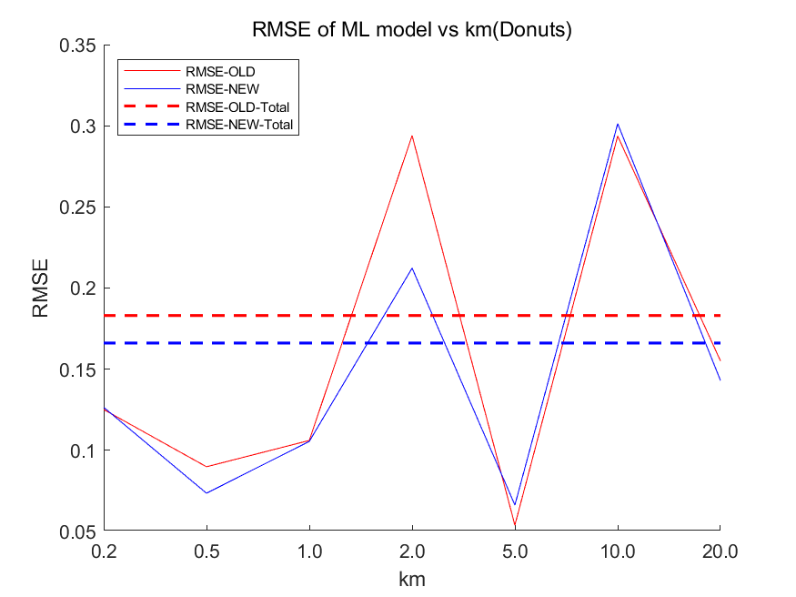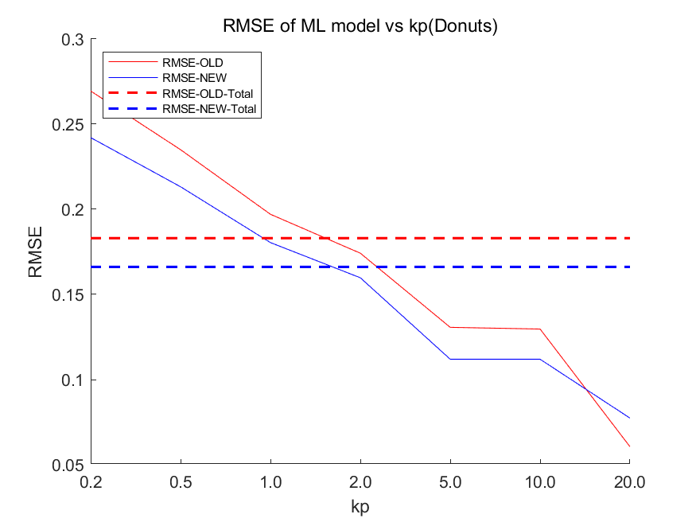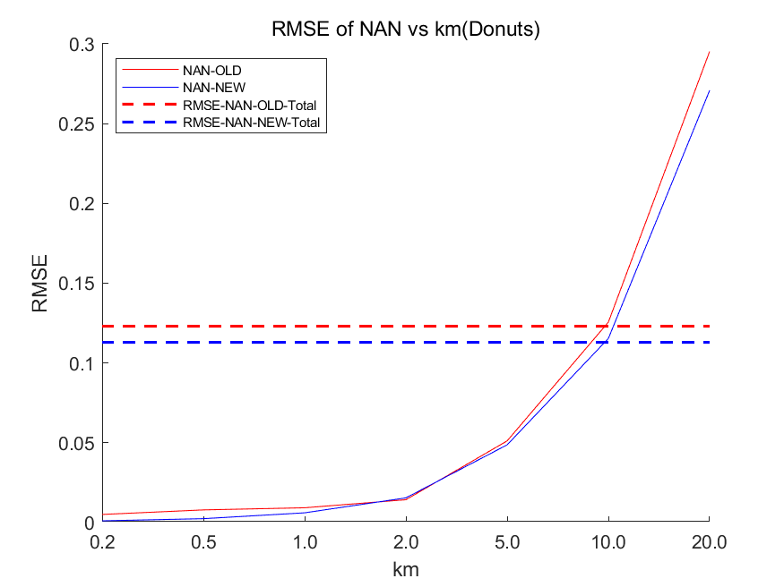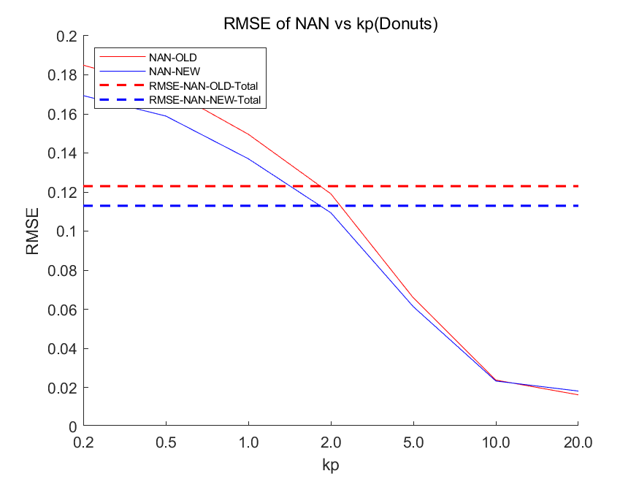

The RMSE result also shows that the predicted p value is better.

**4.3.3.1 Volume fraction: 0.04618**

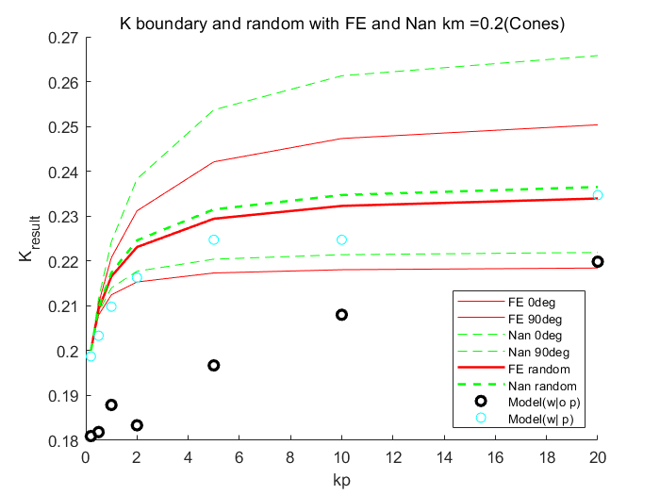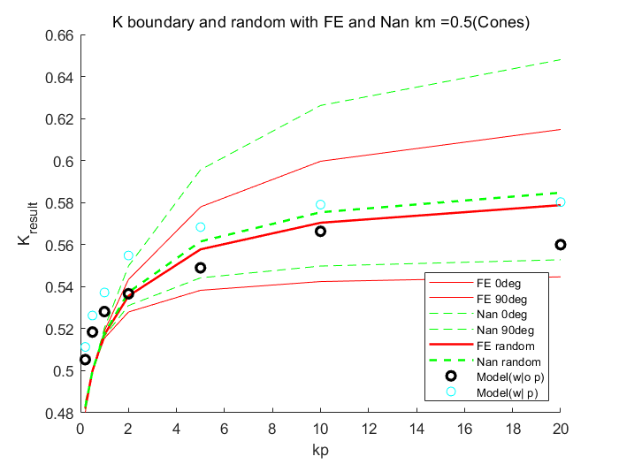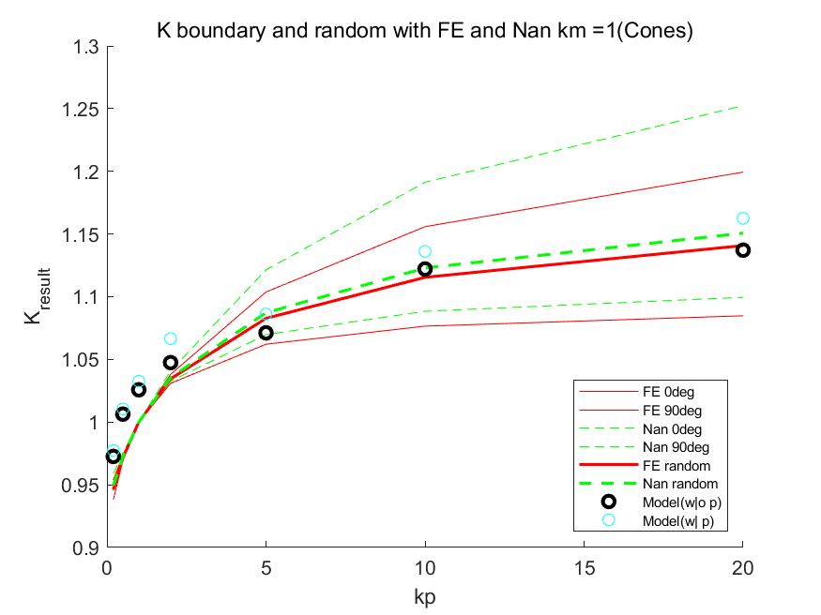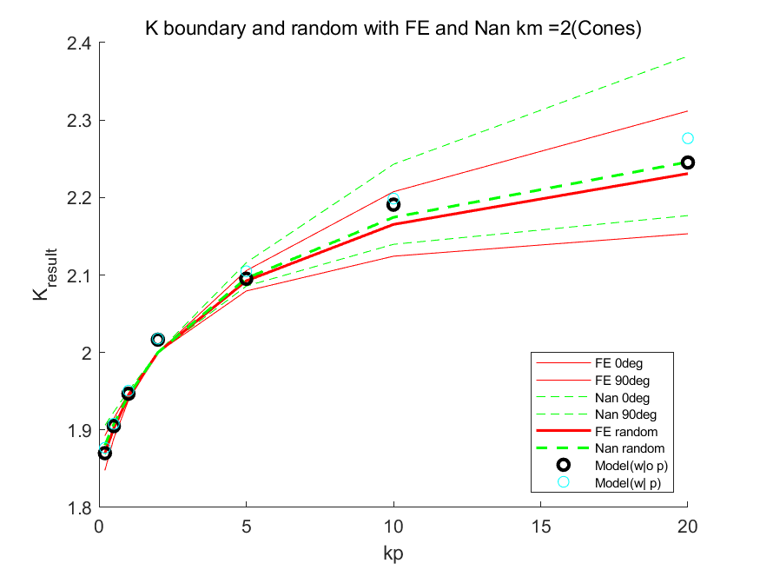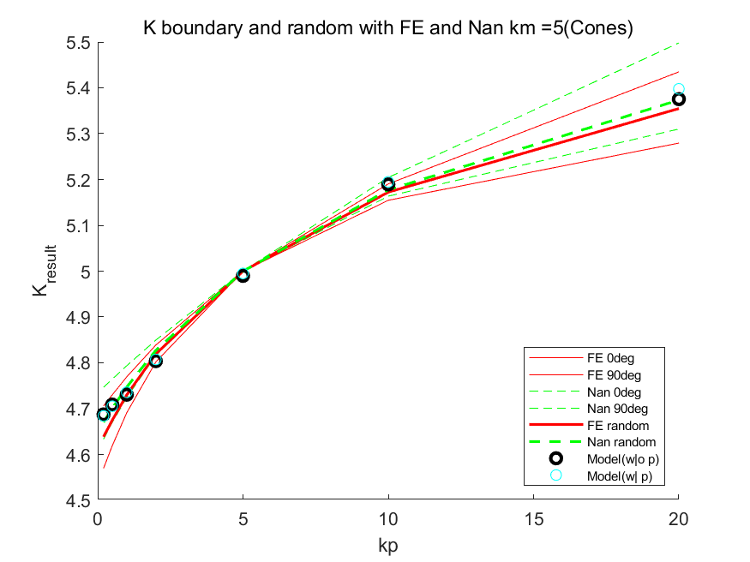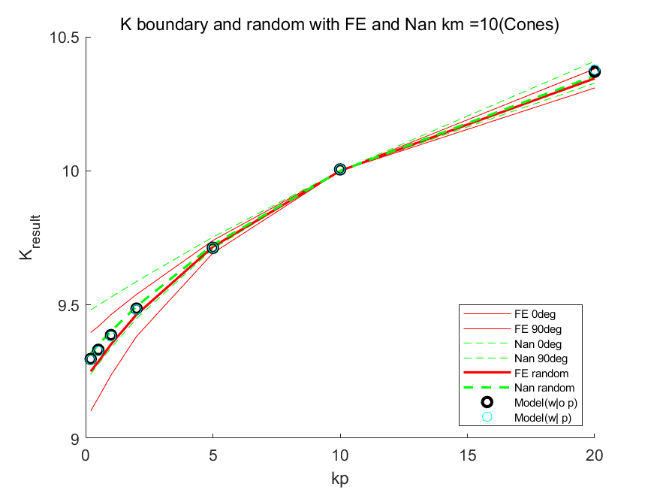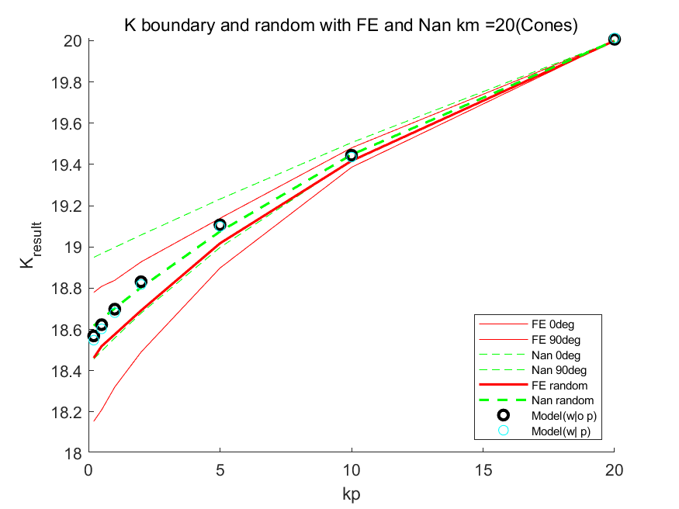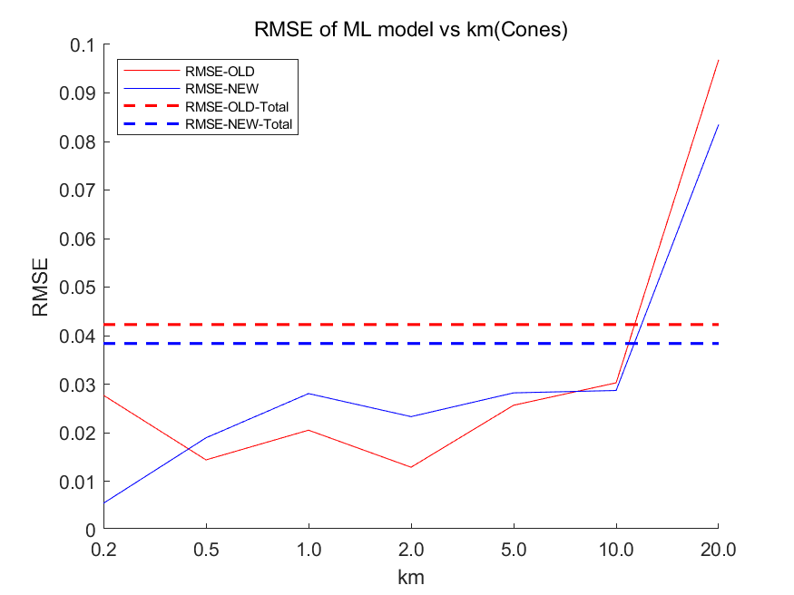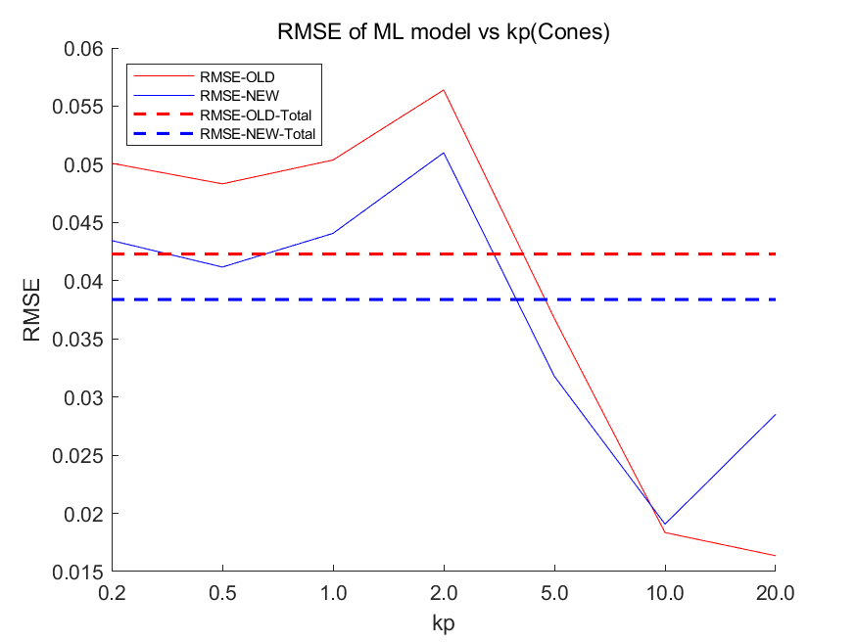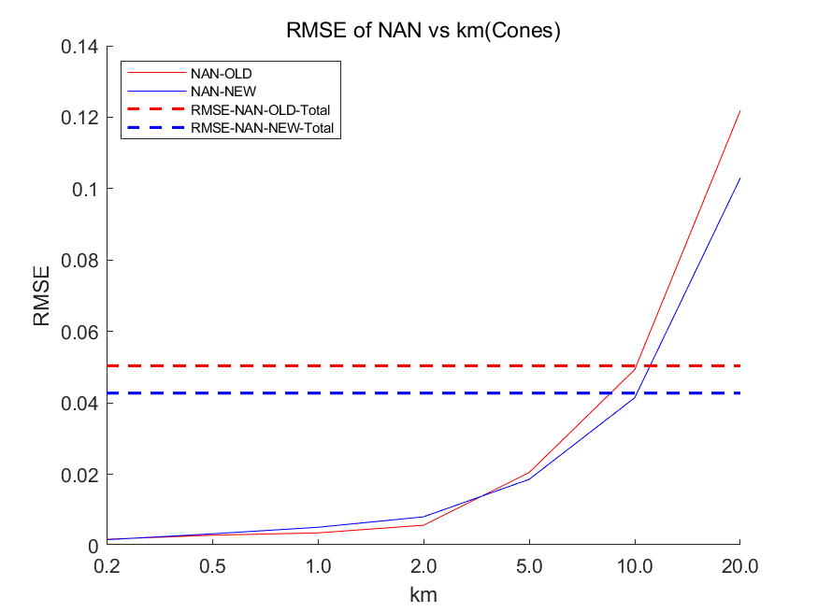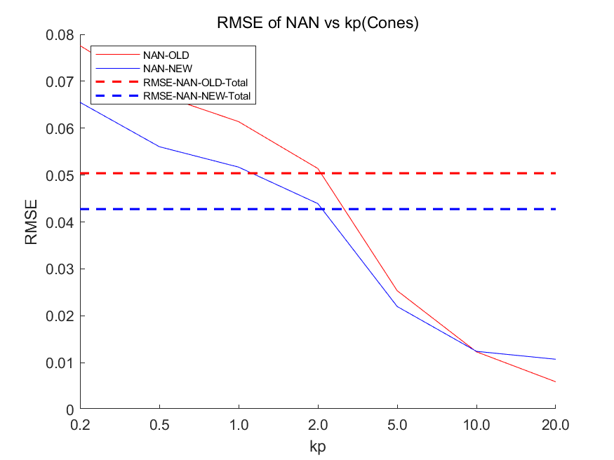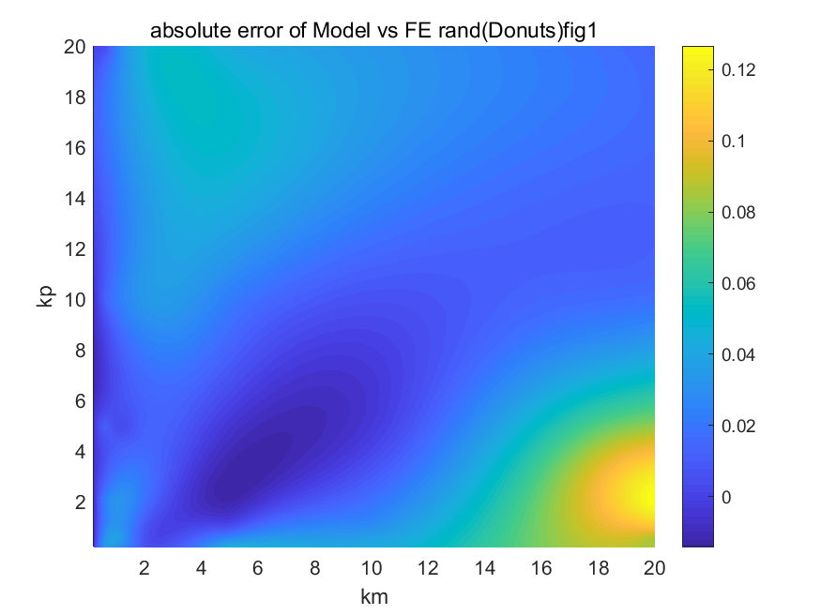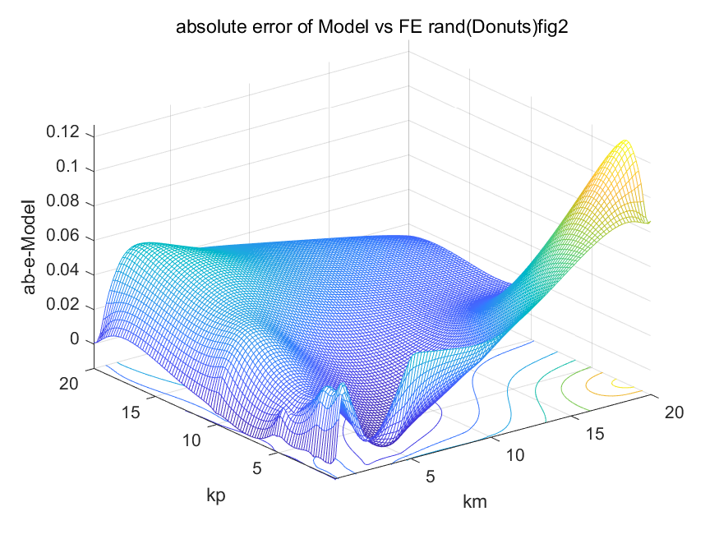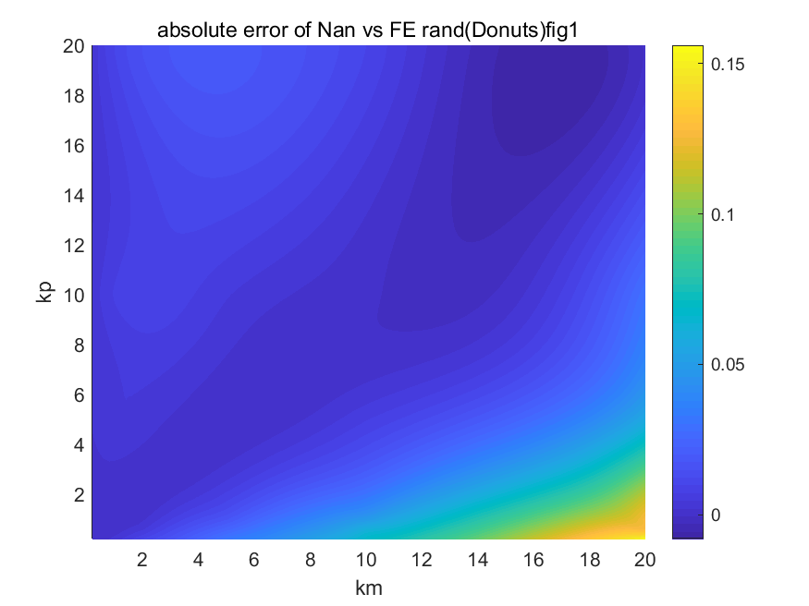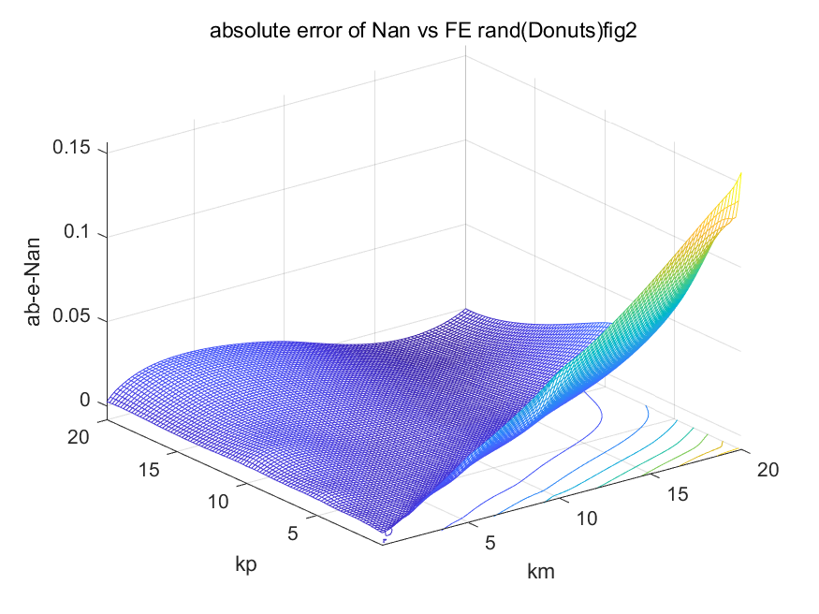

**4.3.4 Helix**

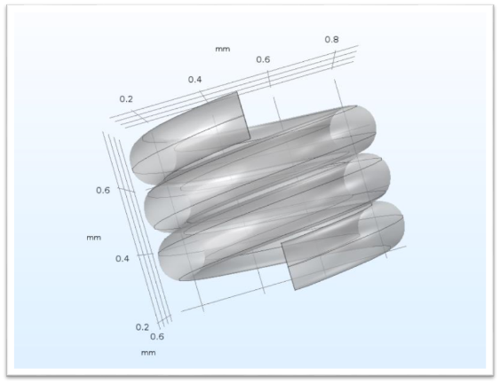

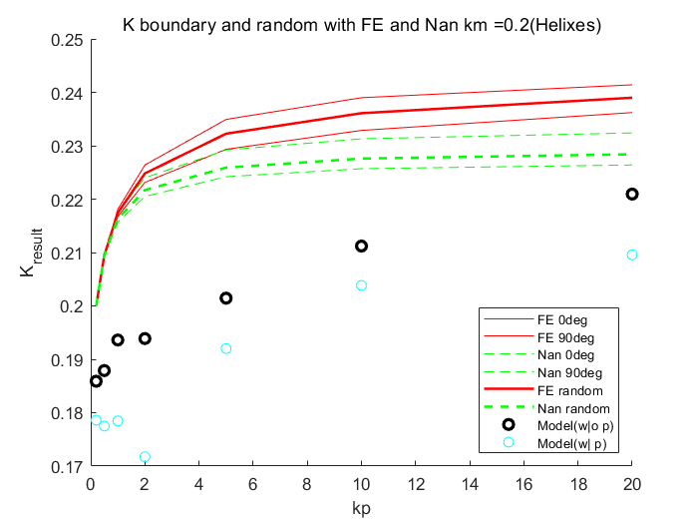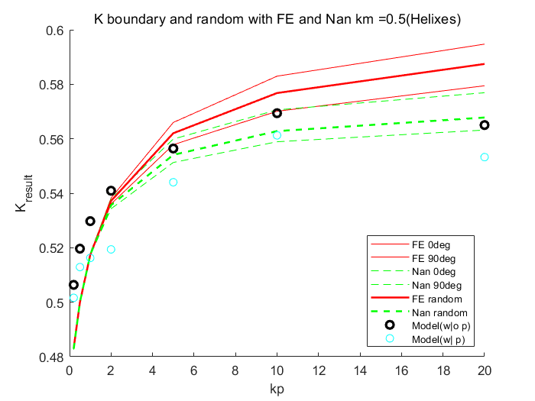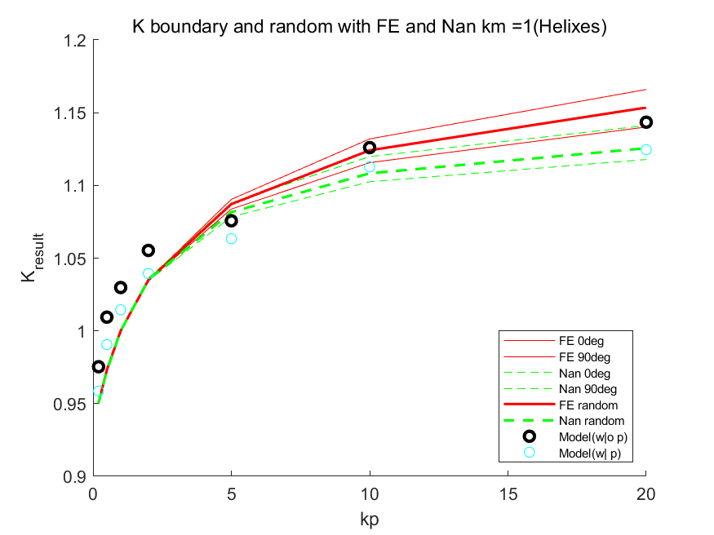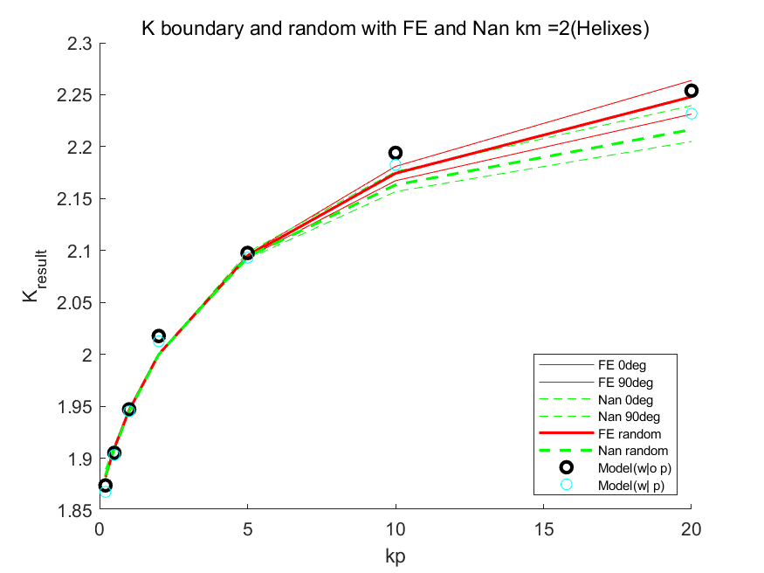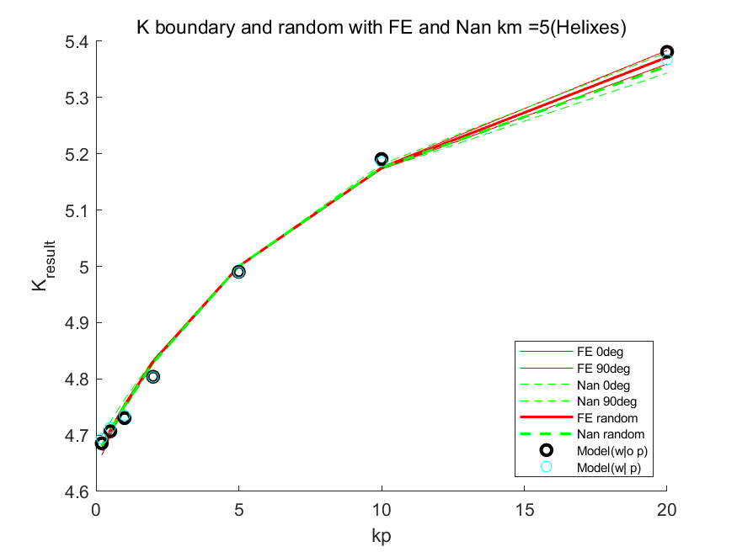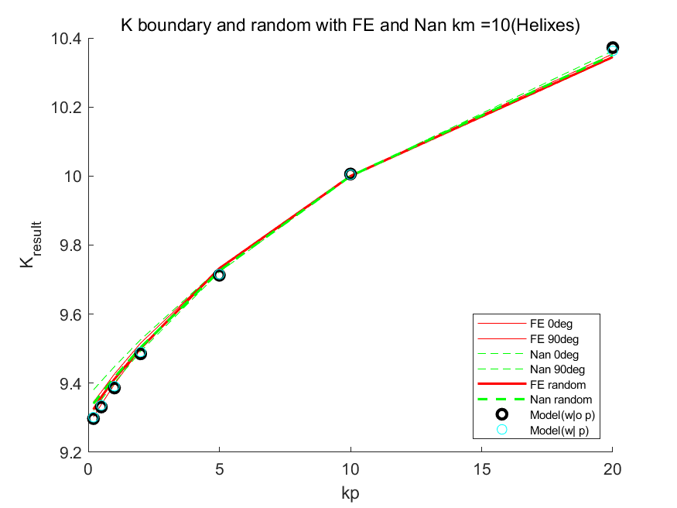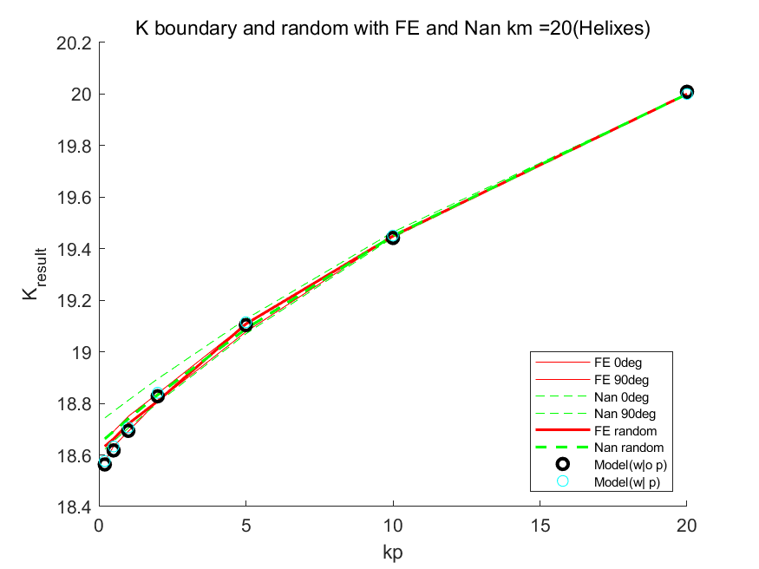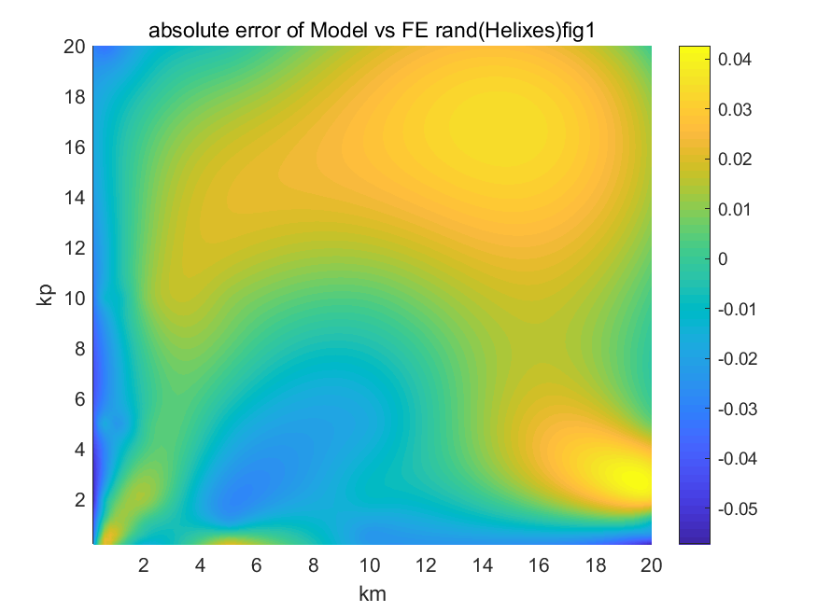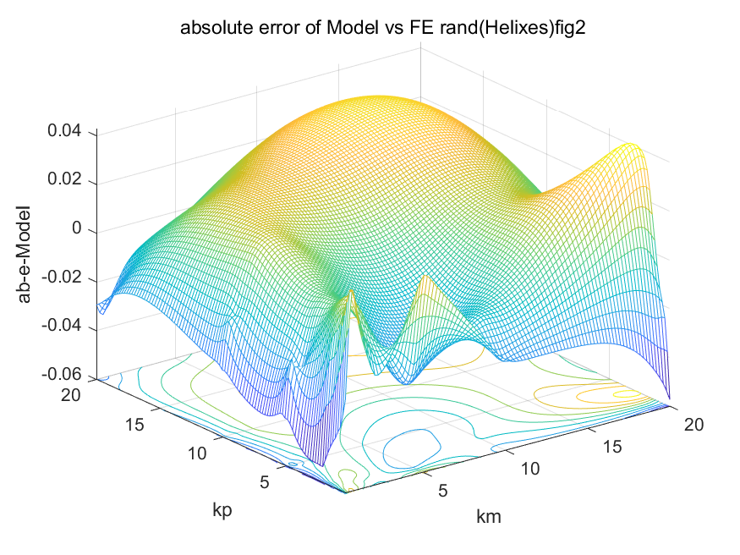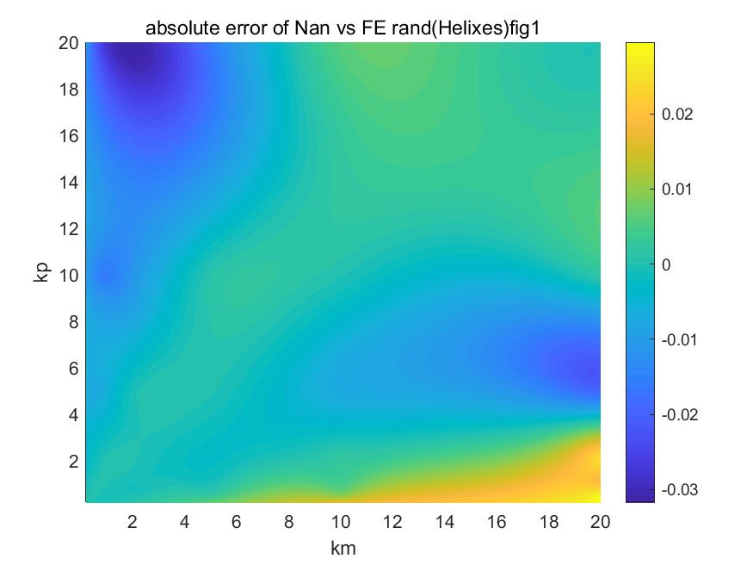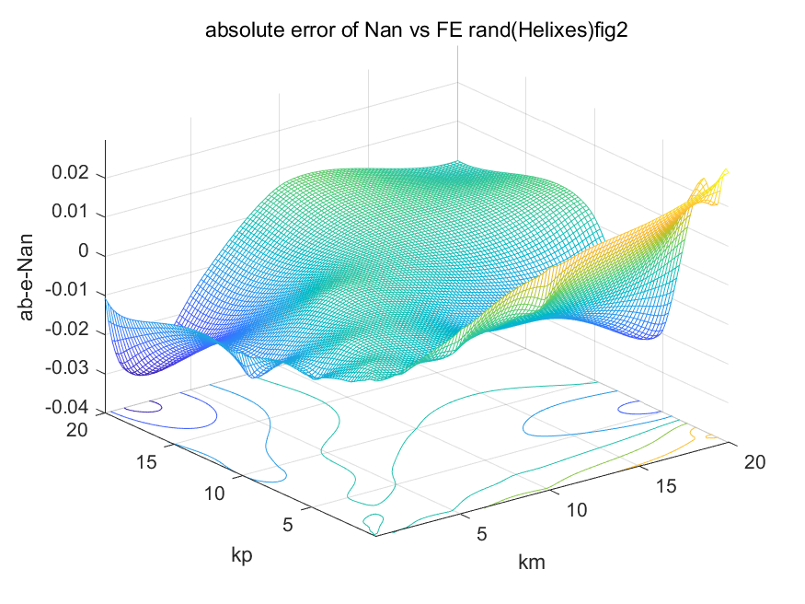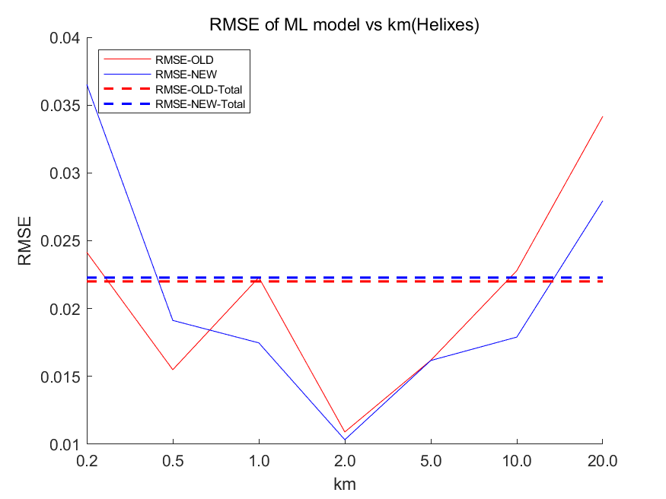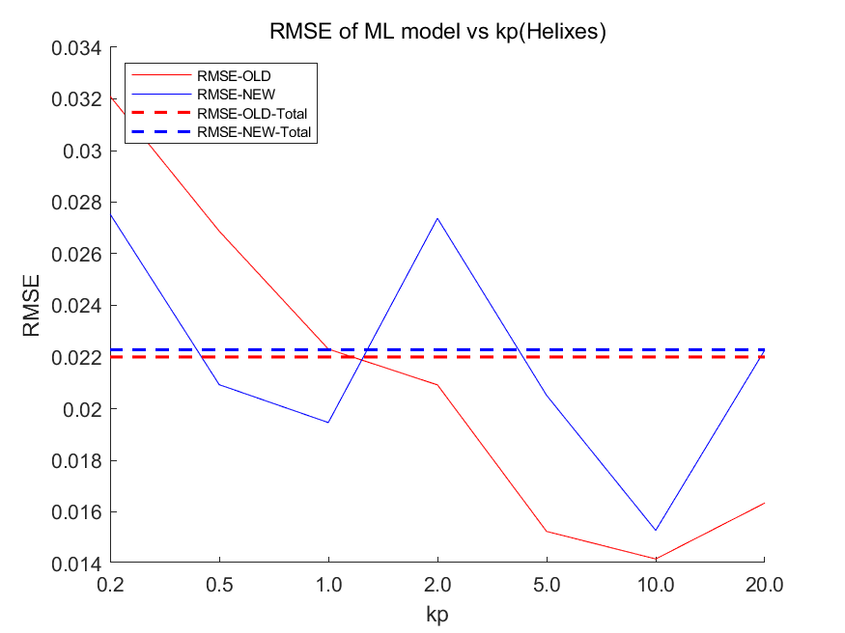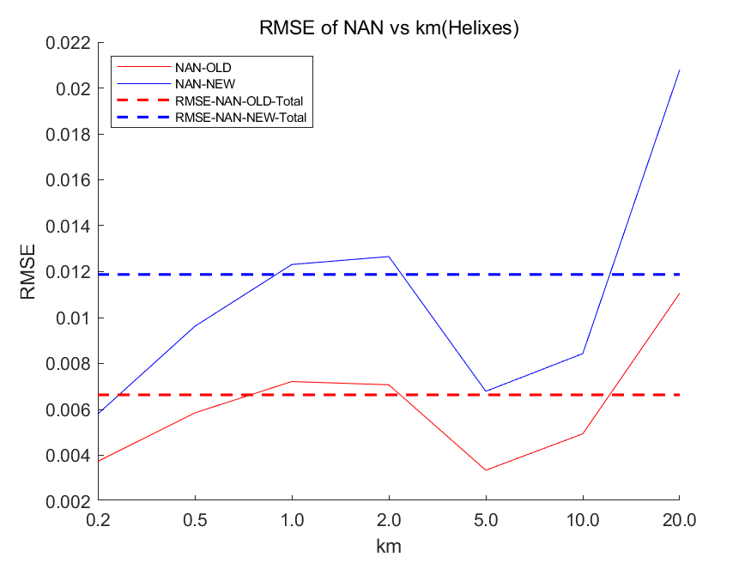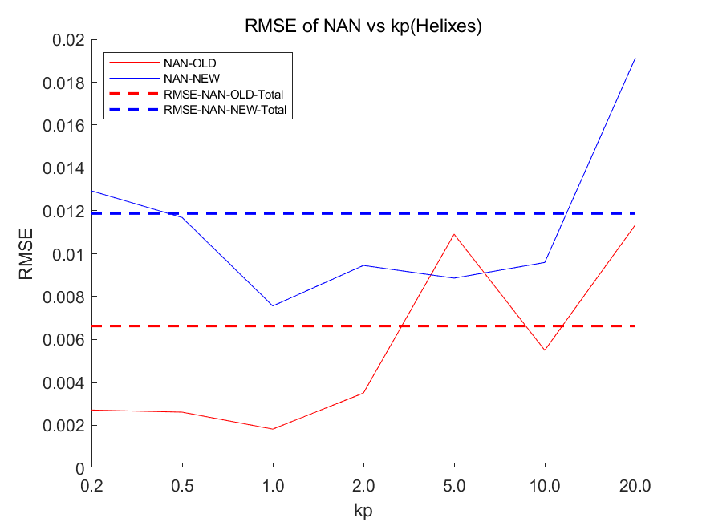

1. **Conclusion**

We trained and evaluated two models in this work. The conclusion is that using the P model to predict a p value for one particular particle shape and plug the p value into the Nan’s formula is an accurate and effective way to find the conductivity of one particle shape. Also, we can see that the RMSE increases as Km increases and decreases as Kp increases.